Tuesday
Morning Maths
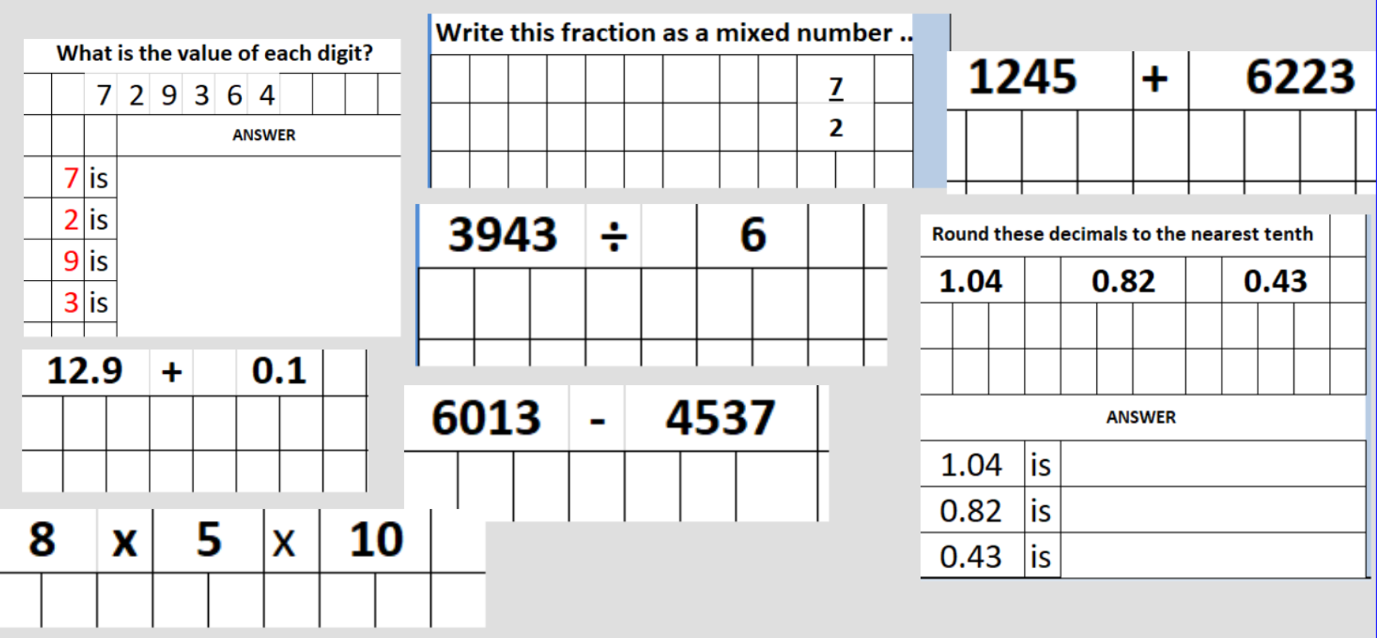
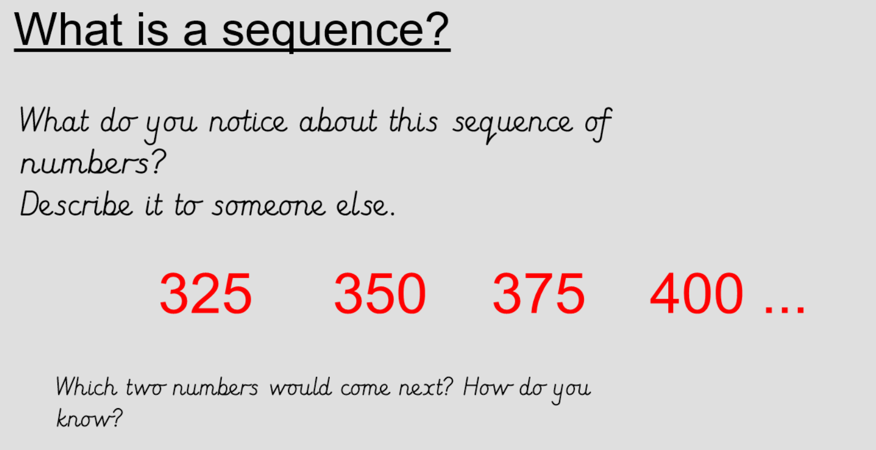
What is happening each time? What do you need to do to work out which number comes next?
1. Find the difference between the numbers in the sequence.

2. Add the difference on to the end number in the sequence.

3. Subtract the difference from the first number in the sequence.

Activity

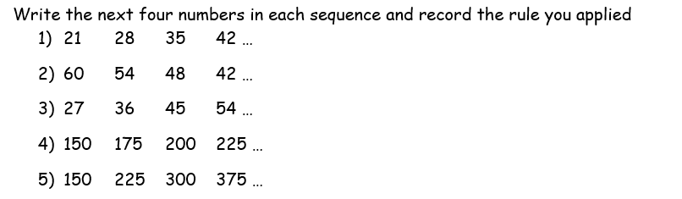
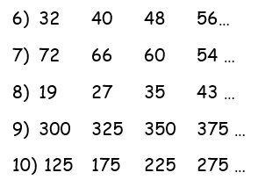
Challenge
