Wednesday 1st April 2020
Maths Lesson 3
7.
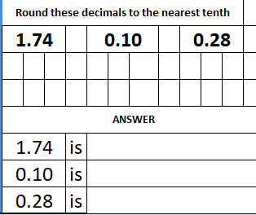
8. 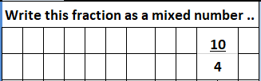

9. 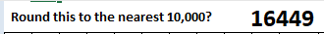

10. 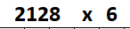

Mental Maths
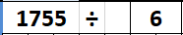

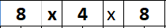

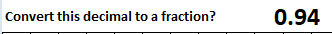

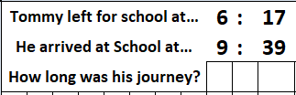

Activity – Sequencing numbers
- Find the missing numbers.
- 2, 5, 8, 11,

- 11, 17, , 29, 35,

- 98, , 122, 134, 158,

- 111, 100, , 78, 67,

- Write two different sequences where the rule to find the next term is ‘add 3’.

- For each of the following, find the missing numbers and describe the rule:

  - , 14, 11, 8, , 2,

  - 38, 49, , , 82

  - , , 71, 62, , 44

  - 98, , 82, 74, 66,
Challenge 1
- Does the number 62 appear in the following sequence?

6, 10, 14, 18, …

How do you know?

Challenge 2
- Jack writes down 3 sequences:
2, 5, 8, 11, …
3, 6, 9, 12, …
4, 7, 10, 13, …

In which sequence is the number 29? How did you work it out? Can you work it out without having to work out the rest of the sequences?

