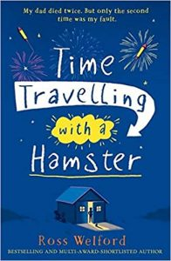
Time Travelling with a Hamster
p. 36 – 37

- ‘I narrow my eyes sceptically, because Grandpa Byron takes a deep breath, closes his eyes, and continues.’

What do you think the word sceptically means in this context?
Once you have written your idea, find out the actual definition online.

- Find and copy two things kept in the precious rooms.

- If you have seen the film Inside Out, explain how it has similarities to what Grandpa Byron is saying.

