Salvation – Good Friday and Easter Sunday

To continue our Salvation unit, we are going to look at how Christians mark two important days during Holy Week: Good Friday and Easter Sunday.

Watch the video below, showing children from different Christian denominations, and note down how they remember/celebrate the two days.

https://www.bbc.co.uk/programmes/p02mww94

As you watch, consider these questions:
- What do the children do?
- What do the clergy (priests, vicars etc.) do?
- What do people remember?
- How do people feel?
- What do people make?
- What do people say?

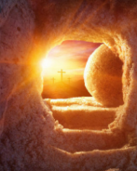
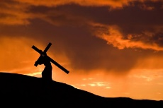
Good Friday Easter Sunday

Project

Use the links below to find out what churches do to celebrate Palm Sunday, Good Friday and Easter Sunday.

You could present your information as a poster, leaflet (using our non-chronological features from this week’s English) on in whichever creative way you choose.

https://request.org.uk/restart/tag/easter-story/

https://request.org.uk/restart/2017/02/23/make-an-easter-garden/

https://www.youtube.com/watch?v=Nfnhv5h0k4M

https://www.youtube.com/watch?v=wq-NhRUIejo

https://www.bbc.co.uk/teach/ks2-religious-studies/z6pbqp3

https://www.topmarks.co.uk/Easter/

https://request.org.uk/

I can’t wait to see what you learn about Easter, and look forward to sharing your projects with Rev. Harry and everyone else!

