Week 2 Science Investigation

Animals including humans

For this investigation, you will need; hands, a ruler, objects to grab.

We are all different and our body parts all differ, as we are all unique (meaning unlike anything else).

However, as we grow, our features and bodies change.

Is there a pattern in how the older we get, the bigger our hands get?
Look at your families hand sizes. Use the ruler in the pack that was sent home to measure each persons hand span. Record these in a table in cm.

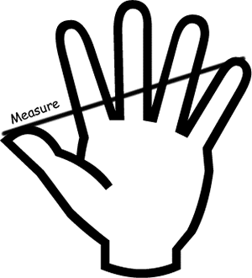
Name | Hand Span (cm) | Objects Grabbed

Now, you will need some items to grab. The smaller the better e.g. Lego, smarties, blocks, pasta pieces. Each person needs to take it in turns to grab as many objects in one hand as possible.

Investigate:

- Can the people with the biggest hands grab the most sweets/toys?

Record and evaluate your findings and send them back to me

