Year 6 Reading Spine
 | Autumn 1 | Autumn 2 | Spring 1 | Spring 2 | Summer 1 | Summer 2
Our Belief and Vison | At The Academy at St James we have books at the heart of learning. We use quality texts to inspire and drive all our learning.  We believe that children learn best when engaged with exciting and stimulating learning, allowing them to grow and develop into independent and resilient learners. In our school we support every child to reach their potential: Aspire, Achieve, Believe.  “The more that you read, the more things you will know. The more that you learn, the more places you’ll go.” Doctor Seuss
Our Values | Community  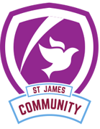 | Peace  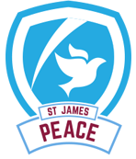 | Respect  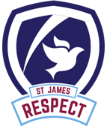 | Forgiveness  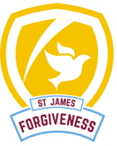 | Courage  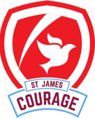 | Trust  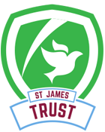
Themes | Only the Brave | Only the Brave | Impressions in Time | Impressions in Time | Mission Impossible | Mission Impossible
English | 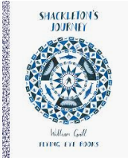 |  | 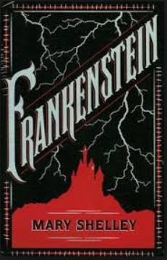 | 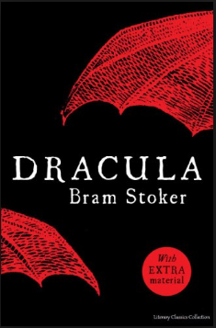 | 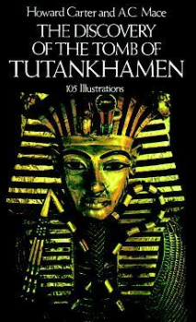 | 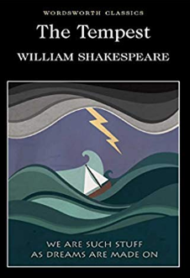
Whole Class Reading | 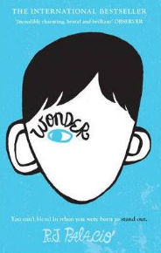 | 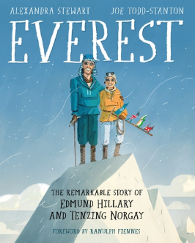 | 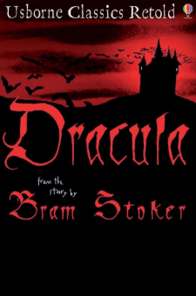 |  | 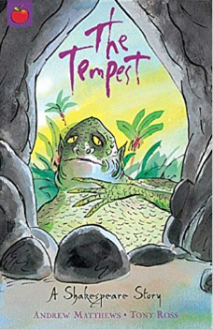 | 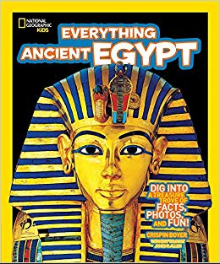
Writing Focus | Poetry: Invictus  Fiction: Journey/Quest Narrative  Non Fiction: Diary Narrative | Poetry: Still I Rise  Fiction: Dangerous Setting Narrative  Non Fiction: Newspaper Report | Poetry: The Highway Man  Fiction: Dual Narrative- Warning Story  Non Fiction: Persuasive Letter | Poetry: The Raven  Fiction: Conquering the Monster Narrative  Non Fiction: Balanced Argument | Poetry: Ozymandias  Fiction: Rags to Riches Narrative  Non Fiction: Informal Letter | Poetry: A Thunderstorm  Fiction: Revenge Narrative  Non Fiction:
Curriculum Theme | At the start of the year we investigate Bravery and the different ways it looks.  During the term we explore Antarctica and how the people and specialist animals survive in this hostile environment.  We also look at how we can use inspirational people to inspire ourselves and discover the effects these courageous individuals had on society.  In Evolution and Inheritance we explore how Charles Darwin changed the way we view the world. |  | This term we take a step back in time to the Gothic Period, a period of new ideas and supernatural elements.  We also learn about Impressionism and how this artistic movement revolutionised the art world, breaking the rules as they went.  In Electricity and The Human Body, we develop our scientific understanding of these subjects, linking them to our Gothic protagonists. |  | To end the year we travel 3000 years into the past to awe-inspiring era of the Ancient Egyptians, where we investigate their culture, beliefs and the impact this crucial civilisation had on the world.  In Light, we investigate how we see the world around us and discover the mechanics of a how an eye works.
Curriculum Texts | 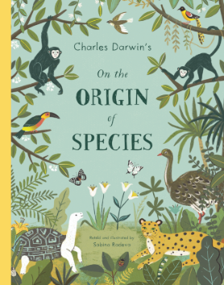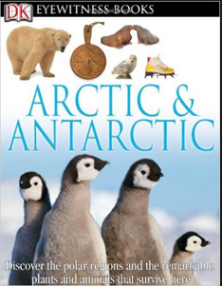  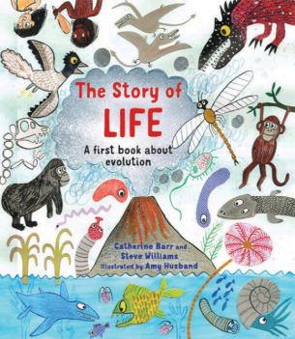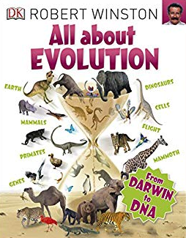 | 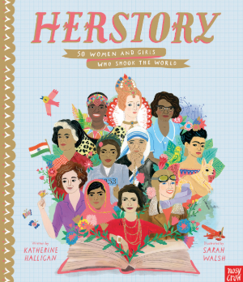  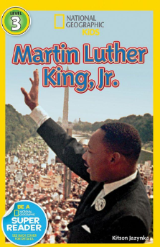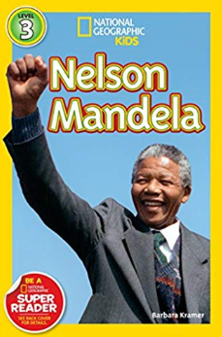 | 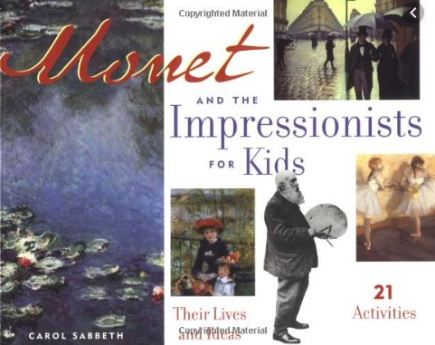  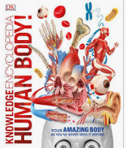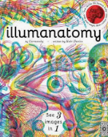 | 