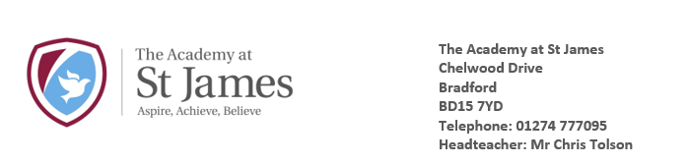

Friday 20th March 2020

Dear Parents and Carers,

The government has set out plans on how it will support pupils eligible for free school meals.

All children who are eligible for free school meals will be offered a daily meal if they can no longer attend school due to coronavirus measures.

If children are eligible for a free school meal and are staying at home due to the school closure, the school kitchen will be making packed lunches for families to collect. If you require a packed lunch for your child or children, then please can you contact the office via phone or email as soon as you can. We will require information such as name of child, dietary requirements and a preferred time you would be able to collect.

To avoid large groups of people gathering together we will try and stagger the time slots that families can collect. Please collect these from the kitchen door at the side of the school. You will be required to give the name of the child/children you are collecting a meal for. These meals are ONLY for children who are eligible for free school meals.

School will be serving a hot meal to all children who are eligible for a free school meal. These meals will be served on a Monday, Wednesday and Friday at 12pm. If you would like to take up this offer, please could you inform the school office by phone or email.

If we have confirmed that your child is attending school from Monday, they will receive a daily meal from our kitchen. You are welcome to send your child with a packed lunch. Please can all parents send their child to school with a named water bottle that is taken home, washed and refilled every day.

If as a family, you find yourself in a financially challenging position or if you need any help with food then please contact the school via the school email (office@academystjames.com ) and school will look to support as much as possible.

Yours sincerely,

Mr Tolson
Headteacher

