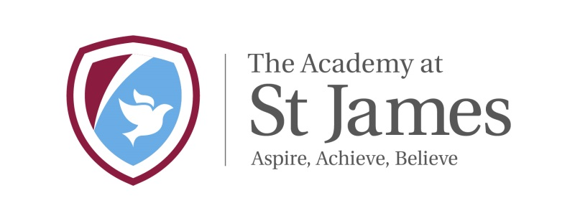

The Academy at St James

Chelwood Drive

Bradford

BD15 7YD
Telephone: 01274 777095
Headteacher: Mr Chris Tolson

Dear Parents and carers,
Thank you for following the guidelines and keeping your children at home. The best place for them is at home if they can be but we realise that for a small minority of parents of key workers they need to be in school. We have been running a small childcare facility for these children.
As we informed you last week following Government advice your local school has now closed for all children other than those of key workers and those most vulnerable children in our community.
For a list of key workers visit: https://www.gov.uk/government/publications/coronavirus-covid-19-maintaining-educational-provision/guidance-for-schools-colleges-and-local-authorities-on-maintaining-educational-provision.
The latest definition and guidance on vulnerable children is here: https://www.gov.uk/government/publications/coronavirus-covid-19-guidance-on-vulnerable-children-and-young-people
We are endeavouring to keep open childcare facilities for those children who need it most and who fit in the categories above.
Please can I remind you that if do not fit in this category, or can make alternative arrangements, the clear government advice is during this difficult time you should keep your children home rather than send them to school where possible.
It is NOT compulsory for key workers' children to attend school if there are other options available. We are offering only essential childcare provision for those families who have no other options. If you have children who can be left at home safely because there is adequate care. The whole point of this approach is to reduce the spread of the transmission.
Therefore schools are "open", but literally only want the absolute minimum number of absolutely essential number of students, so that they can deploy the minimum number of staff and therefore expose the minimum number of children, staff and their families to this risk.
Remember to keep working with your children at home using google drive, class dojo and our website.
As you have seen over the weekend, the government’s advice with regards to social distancing has gotten stronger and stronger with us being told to stop all essential contact. Unfortunately for key workers and their children, this is harder to implement. There are some precautions we can take to try and stay as safe as possible.
If your child is attending school as they are a child of a key worker or a vulnerable child, they will receive a daily packed lunch provide by the school kitchen. Please do not send any packed lunches into school.
For children who are staying at home due to the school closure the school kitchen will be making packed lunches for families to collect if you are eligible for free school meals. If you require a packed lunch for your child or children, then please complete the google form you will have received via text. If you do not complete the form we will presume you do not need the meal unless you ring school and contact us.
Please collect these from the table outside the main entrance and sign the register so we know who has collected them. These meals are ONLY for children who are eligible for free school meals (this does not include universal infant free school meals).
If your child is eligible for free school meals but you are unable to collect food packages from the school, then please contact the school via email.
If as a family, you find yourself in a financially challenging position then please contact the school via the school email (office@academystjames.com) and school will look to support as much as possible. If you have any queries or doubts please contact.

Kindest Wishes

Christopher Tolson
Headteacher

Am I a ‘critical worker’ to the COVID-19 response?

NO
YES
Whilst we understand the importance of you working from home, we strongly recommend that your child stays at home to limit the chance of the virus spreading
As one parent/carer is not a ‘critical worker’, we strongly advise you to keep your child at home and do not send them to school.
Keep your child at home. Do not send them to school!
THE SCHOOL CAN PROVIDE CARE FOR YOUR CHILD TO HELP YOU
NO
Are you able to keep your child safe at home?
i.e. That at least one parent/carer is working from home
YES
Are both parents/carers ‘critical workers’ to the COVID-19 response?
NO
YES

