History – Lesson 2
We know the Anglo-Saxons came to Britain, but how do we know this?
Look at the picture below. It is a picture of an Anglo-Saxon burial ground known as “Sutton Hoo”.
How reliable is this picture as a source of evidence that the Anglo-Saxons were here? Does the picture look real? Could it have been faked? What do you think?
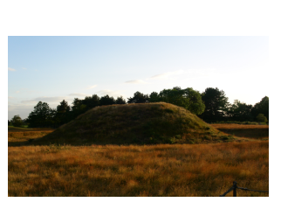
This text below is written in the British museum and is about Sutton Hoo.
Because this is written in a museum, do this mean that Sutton Hoo is real?
How reliable is this text as a source of evidence that Sutton Hoo is real?
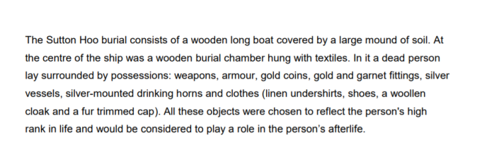

Use the websites below to find out what you can about the evidence we have to prove the Anglo-Saxons came to Britain.
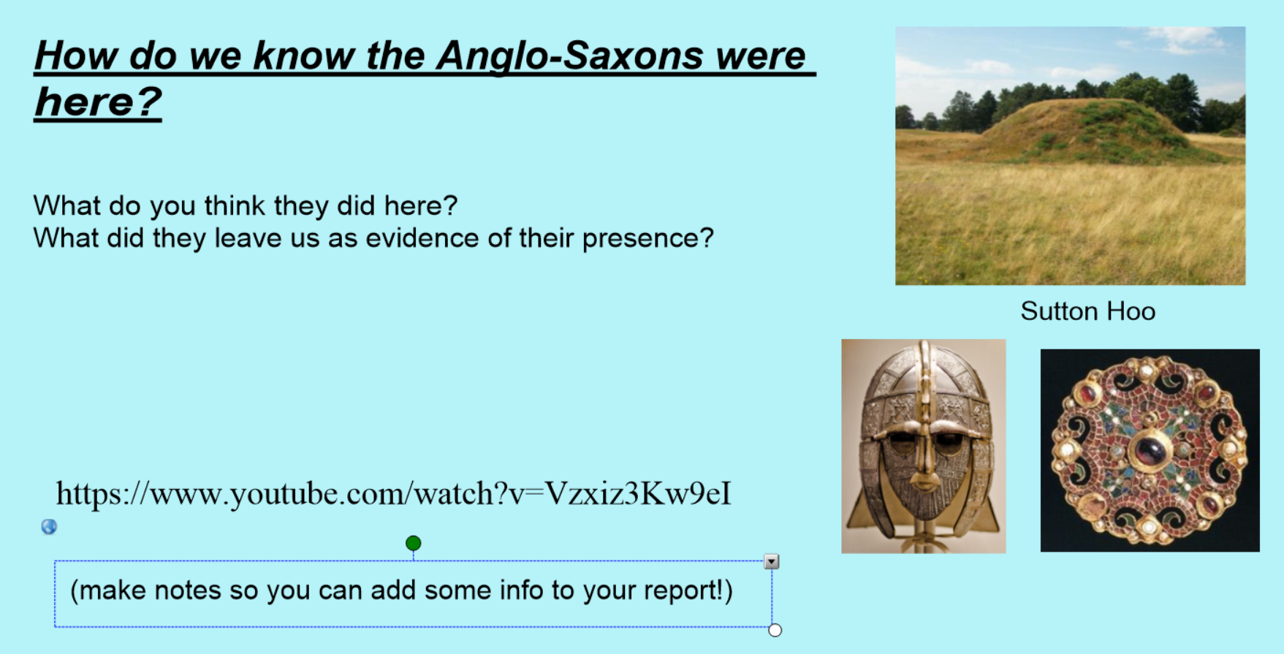
https://www.youtube.com/watch?v=Vzxiz3Kw9eI
http://www.primaryhomeworkhelp.co.uk/saxons/suttonhoo.htm

What was found at Sutton Hoo? What did the Anglo-Saxons bury there?
Apart from Sutton Hoo, what other evidence is there that the Anglo-Saxons were here? What impact did they have on our country?

