RE – Salvation
Key Question – Was Jesus a “good shepherd”? Did he lead his people well and keep them safe?
Write your thoughts down and then discuss it with other people in your family. What do they think?

Read the following scenario and answer the questions.
How does this link to Jesus death/ sacrifice?

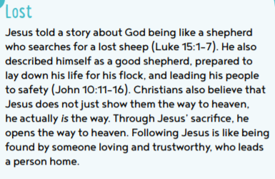

Read the parable

The Story:
Some of Jesus’ followers thought that God loved some people more than others. They thought that some people were important and some people were not important. They asked Jesus a question, “Teacher, who is the greatest in the kingdom of heaven?”
Jesus asked a little child to come stand by him. He told his followers that even a little child is important to God. Everyone is important to God.
Jesus wanted his followers to understand this better so he decided to tell them a story to help them understand. This kind of story is called a parable. This is the parable of the Lost Sheep.
Once a shepherd had a flock of 100 sheep. The shepherd loved every one of his sheep. He even had names for his sheep. Every night he would count his sheep to make sure that all 100 were there.
He helped the sheep find the best green grass. He looked for nice clean water so his sheep could have a nice drink when they were thirsty.
Sometimes dangerous animals like bears and lions would come and try to hurt his sheep. The shepherd protected the sheep and chased all of the dangerous animals away from them.
Sometimes the sheep would wander away from the rest of the sheep and the shepherd had to call out the sheep’s name. When the sheep heard the shepherd’s voice he would run back to the shepherd.
What would it mean if the shepherd counted his sheep and he counted only 99? That would mean that one sheep was missing. How do you think the shepherd felt? What do you think the shepherd would do? Do you think the shepherd would just say, “Oh, well, who cares? I’m just happy that the 99 sheep are okay. I won’t worry about just one little sheep. One little sheep is not very important anyway.”
What would you do if you were the shepherd?
The shepherd would leave the 99 sheep in a safe place and then he would go and look for the lost sheep. He would look behind bushes and in the deep valleys. He would keep looking everywhere until he found the sheep.
When he finally found the sheep he would be so happy! He would lift the sheep up onto his shoulders and carry him back to the other ninety-nine sheep. At last, the shepherd could be happy because all of the sheep were safe and well.
After Jesus told this parable he explained what it meant. God does not look at one person and say, “This person is important. She’s the greatest in the kingdom of heaven.” And he doesn’t look at another person and say, “This person is not important. He is the least in the kingdom of heaven.”
Every single person – even the littlest child – is important to God. He does not want even one single person to be lost.
Did you know that you are important to God?

