**Pupil star of the week**

**CC:** Freddie- For always being so enthusiastic. You are a super star!

**BB1:** Fabian who has completed every challenge so far and all with a smile.

**BB2:** Joshua Gombe for tackling all his challenges with enthusiasm and positivity.

**GG1/2:** Leighton Leddy, for continuing to complete daily challenges with a positive attitude.

**HH1/2:** Rayyan Mahmood (and family) for challenging himself and completing lots of different challenges - the whole family have got involved :)

**RR1/2:** Bernice Yeng Qien Chan for all the amazing work she has been completing at home.

**FF3/4:** Roksana Paczkowska for her extraordinary dedication to learning, exercising and having fun. Adults at school and on Twitter have been amazed by your effort!

**PP3/4:** Anayah Rani - for a great effort in completing daily challenges and being a great sport this week in school

**FLF3/4:** Rylan Wardman- For trying so hard at home and completing all the activities provided!

**DD5:** Oliwia - for always being enthusiastic and completing her work.

**DYD5:** Zach Mousa - For responding so well to feedback and going the extra mile. Well done :)

**OO6:** Milena Zacny -For all her wonderful work which she has uploaded every day.

**BB6:** Hasam Ali-for his wonderful art of noticing poem which was inspired by his adventures outdoors. Well Done

**Parent star of the week**

**CC:** Geraldine (Justyn’s mum) For supporting Justyn with his home learning and for sharing it all on Class Dojo

**BB1:** Rebecca Wilson, Archie’s mum for supporting Archie to do some fantastic home earning.

**BB2:** Cheryl (Mason’s mum) For really encouraging Mason and keeping regular contact with school!

**GG1/2:** Emma Hudson (Summer’s mum) for supporting Summer with her learning after working hard all day as a key worker.  Thank you

**HH1/2:** viktorija zablockyte (Zayn’s mum) for encouraging Zayn to complete many different challenges and sending them to me regularly - thank you

**RR1/2:** Olga Michalska - Maksymilian’s mum. For lots of updates and happy pictures of Max at home.

**FF3/4:** Justyna Tahanom (Armin’s mum) and Kev Marshall (Sarah’s dad) for supporting their children’s learning and their perseverance and patience to upload the work.

**PP3/4:** Kristine (Simona mum) for her continuous energy and enthusiasm for Simona work. She is a grateful as I am. Thank you and have a good Easter

**FLF3/4:** Claire (Rylan's mum) - For continuing to support Rylan and for regularly uploading his work so I can see it!

**DD5:** Mrs Crocker for interacting so well on dojo and supporting the children - great time table!

**DYD5:** Ryan Hodgson (Blossom, Neveah, Honey and Archie’s dad) - For persevering with setting the children’s learning up and for his kind words to our members of staff. Thank you!

**OO6:** Nicola Murtagh - Delyla’s Mum. For always liking and viewing all of the posts on dojo. Always so positive. Thank you

**BB6:** Mrs Turner for persevering with class dojo’s and sending photo’s of Kian’s work! Well Done

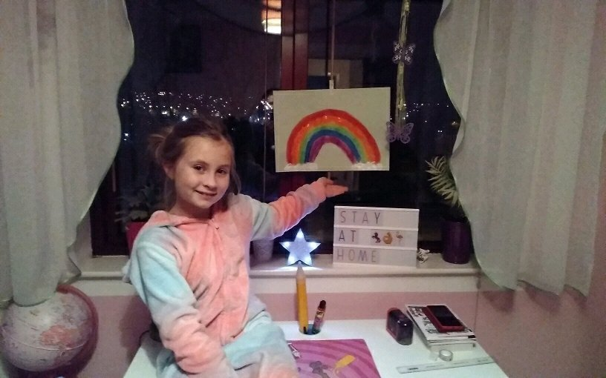

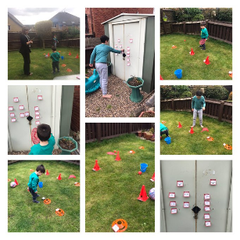

**PE star:** Taking part in Mr O'Brien's joint physically active maths lesson and helping his little brother to move and learn!

**Head Teacher’s comment**

It has been an another amazing week full of great work, funny tweets and dojo posts plus some amazing teamwork from the staff and community at St James. I would like to thank team 1b and all the staff at St James for working together in challenging circumstances. Thank you for your kind comments and for celebrating your children’s work with us. Keep doing your best; some days it won’t happen and that ok. We are all getting used to working in a different way. The best thing you can do is look after each other. #staysafe

**Positive notes**

**Miss Smith:** We have loved learning about The Dinosaur that Pooped a Princess this week. I have had some amazing challenges sent back.

**Mrs Pitts:** The highlight of my day is seeing pictures and videos of the Brilliant Butterflies learning and having fun.

**Miss Croft:**Getting to hear some of Butterflies 2 read. I have really missed it!

**Mrs Gibbons:** I have received some fantastic photographs of children’s learning this week, some children are really challenging themselves to complete everything we have put onto the website and class dojo.

**Miss Greenwood:** Continuing to see all the fabulous work Rabbit’s are doing at home. You are making me very proud!

**Mrs Thompson:** I am so very proud of my little Hedgehogs - you are all doing a brilliant job and making me so happy!

**Miss Petty:** It was great to speak to many children over the phone, it cheered me up hearing your voices :)

**Mr Wallis:** Great week from all children and parents. Keep going and have a good Easter

**Mr Brownsell:** I have loved seeing work, photos, videos and messages from more and more Foxes as the week has gone on and having the chance to chat with some children over the phone. I’m extremely proud of the positivity from my class - so many ‘well done’ messages praising each other’s efforts, and the Rainbow from Kai P made my day!

**Mrs Langley:** I have loved reading the positive comments from the children on their work this week, but have also loved to see the positive praise and thanks from parents and staff on dojo class story and school story. It’s lovely to know people are happy and that they acknowledge and appreciate each other’s hard work. In school this week, the staff and children have been happy and all worked as a team again. Another lovely week!

**Miss Rosenberg:** I had some lovely conversations with some children in my class this week, it was great to hear them giggling and still very happy :)

**Mrs Parker:**  The lovely comments on Dojo’s from other parents and teachers about Year 6 work. What a super community we have!

**Mrs Allingham:** The wonderful support that parents and other staff are giving to each other on the various platforms. Keep smiling everyone.

**Important Notices**

**Google classroom**

We have become aware that some people are still unsure where to find work on google classroom so we have attached a picture below to help with this. Go to the task bar at the top of the page and click on the tab that says ‘classwork’. This will take you to the work set by your class teacher.

**Class dojo**

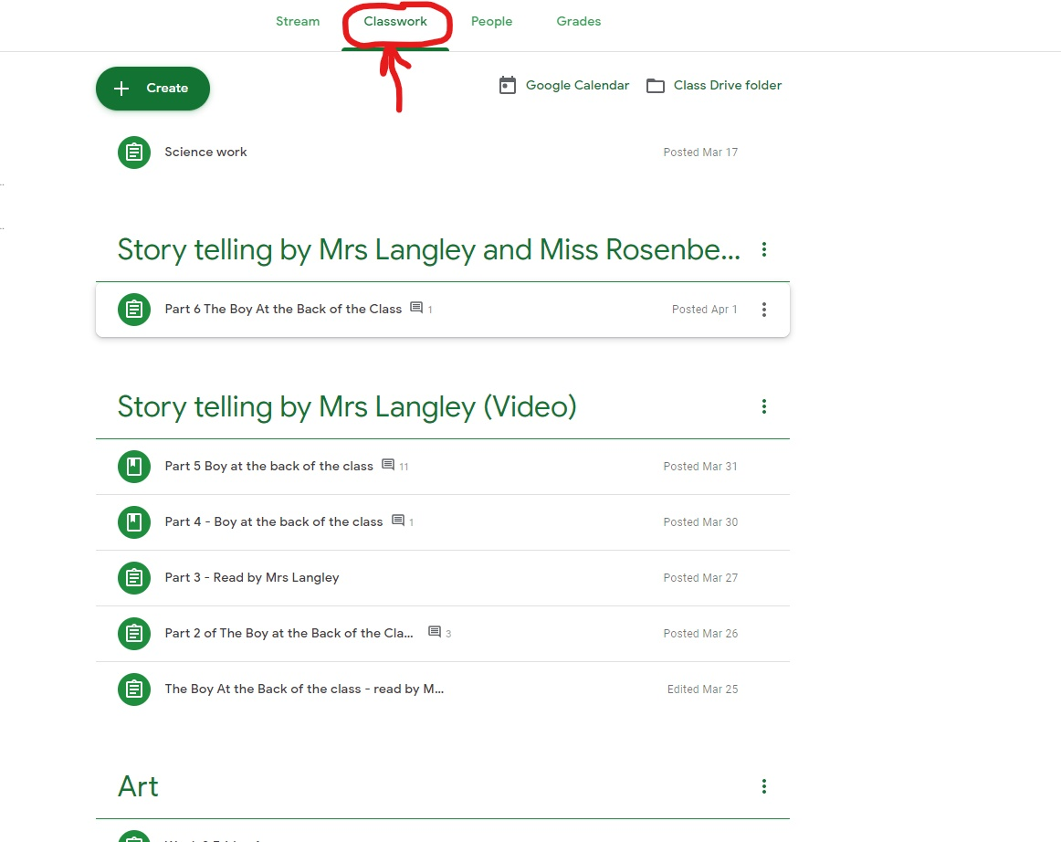

Click here

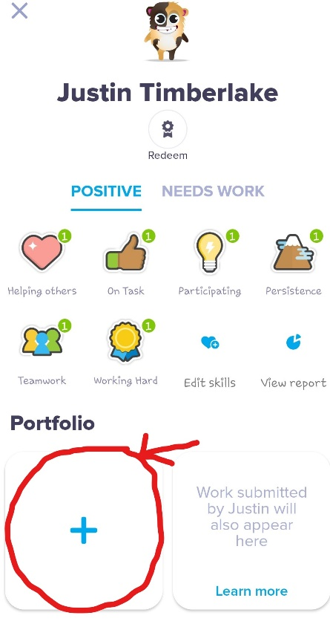

Please can you save your work directly onto your child’s portfolio. This way the class teacher will be able to view it easily and give feedback and award dojo’s. If you are unable to save work to your child’s portfolio please send it directly to the class teacher. We do not want to any work to go unrecognised.

To save work to your childs portfolio, click your childs monster and then as shown in the picture to the right click the add button.

Click here

**Photos from this week**

