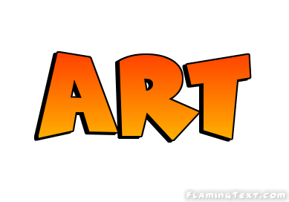
Read through the PowerPoint based on Banksy. What do you think about his work? Is it art or is it graffiti? If you were to create an image based on this type of work, what would it be of? What would the image represent?
