Yesterday, we matched facts about the Second World with the appropriate heading.
Now, I can use those facts, the WAGOLL and all of the non-chronological report features we learnt about in Week 1 to write the first information paragraph of my own report. Remember – this will come after your introduction (2 questions, If so…).
Topic sentence
Heading - question
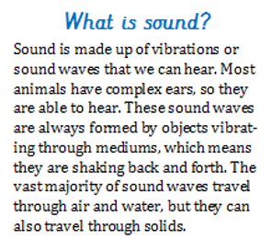
WAGOLL example My example
Why did the Second World War begin?
The Second World War began on 1st September 1939, when Germany invaded Poland. As a result of this attack, British Prime Minister Neville Chamberlain and France declared war on Germany. Many countries had tried to keep Germany’s leader, Adolf Hitler, happy by allowing him to have a larger army and more land. However, he had promised to make Germany strong again, after the country had suffered a loss of jobs, land and its army at the Treaty of Versailles in 1919. Even though Germany had become stronger by 1939, Hitler, his Nazi Party and the vast majority of Germans wanted more.
Features used:
Comparative language Facts/Technical vocabulary
Causal and contrasting conjunctions Generalisers

Over the rest of the week and any time you have over Easter, create your non-chronological report about The Second World War.
Miss Petty, Mr Wallis and Mr Brownsell were impressed with the first attempts that some of you shared, and challenge you to improve them by using:
- Topic sentences - generalisers - comparative language - technical vocabulary
- Causal and contrasting conjunctions

Take your time on them, and make them as big and colourful as you want! Remember to use the facts you already know, and from yesterday’s sorting activity.

Look at the example of a History non-chronological report open to the public in Skipton.
It also includes:
- maps - timelines - images

They make it so much more eye-catching, and will tempt the reader to read the paragraphs.
We would love to see you include these visual features in your non-chronological reports!
