Monday 27th April 2020
English

In 1981 Chris Van Allsberg wrote a book called Jumanji. In the story, a brother and sister discover a game that turns fiction into real life. Whatever square you land on in the game, brings a new challenge to overcome. Worst still, the challenge becomes a reality for everyone around.

If you have access to the Internet, type this into Google: https://cutt.ly/JtxrUyf
This is a link to the original movie trailer for Jumanji in 1995 and you can see the consequences of playing the game! First, check with an adult that it is ok to do this.

Read the extract given to you and then answer the following questions.

- What next?
We’ve stopped at an interesting part of the story. Summarise below what you think could happen next.

- What Do the Words Mean?
Go back through the story and underline any words you don't know the meaning of.

The Sentence Challenge: Take a look at the definitions of the following words from the text. Take each word and put them into new sentences. How many sentences can you create? …

rain streaked the classroom windowpanes.

To streak along – to move rapidly

e.g. John streaked along the pavement towards the crowd.

Now write your new sentences:

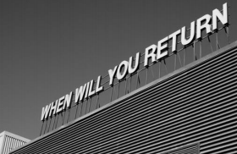
… a resurgence of the game slap

A resurgence – something that returns or starts again after disappearing for a while

e.g. The teachers have seen a resurgence of skipping games in the playground.

Now write your new sentences:

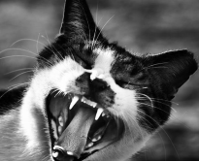
… the ferocity of a wild beast

Ferocity – extremely fierce (fierce = strong, powerful, violent or frightening)

e.g. We were surprised by the ferocity of the storm.

Now write your new sentences:

- Likes, Dislikes, Puzzles & Surprises!
Now you have read the whole story, what did you like & dislike?

What puzzled you (what questions do you have – why, what, how …) and what surprised you?

