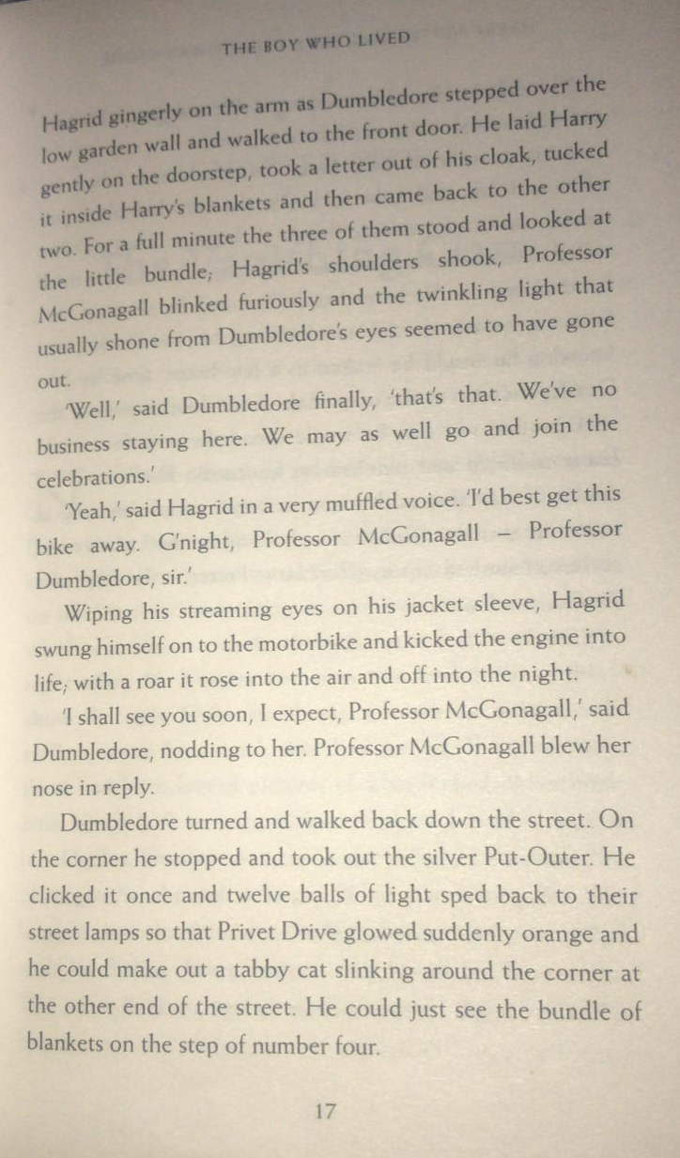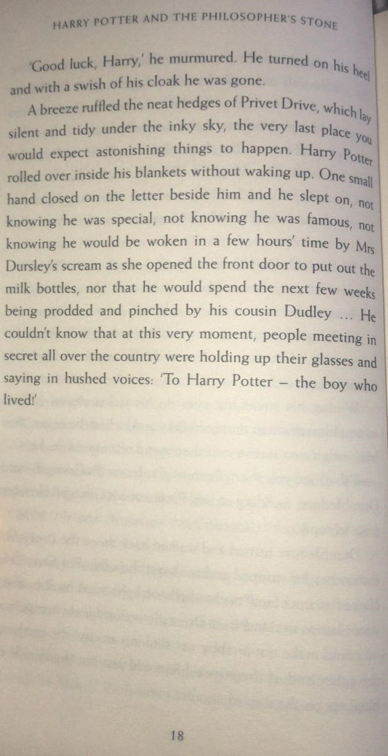
Questions
- Read paragraph 1 on page 17.
Which phrases suggest both Hagrid and McGonagall were crying?
- What happened when Dumbledore clicked the Put-Outer?
- Circle the synonym for 'mumbled'.

ruffled murmured prodded

- Find and copy the phrase that tells the reader that there was a gentle breeze as Dumbledore left.
- What was Mrs Dursley doing when she spotted the baby?

Oracy statement
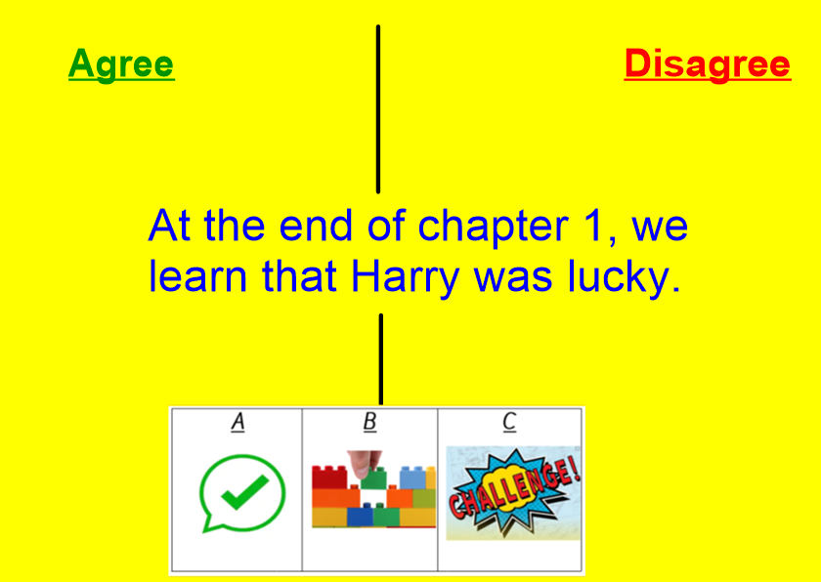
Consider reasons why you agree and disagree with the statement
Upload your thoughts on Google Classroom, either by video, photos of your work on paper or written messages.
Let’s get debating!

