Friday 1st May 2020
English

Continuing with The Game planning
Use the ideas in your boxing up grid from yesterday to help you complete this part.

Follow this pattern: Start with the first strange events as a sentence of three and then show how the children react:

e.g. At that moment, the table began to shake, the windows rattled and the floor vibrated. Everyone stopped what they were doing and the room fell silent.
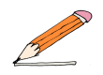
Your turn!
At that moment,

Next, introduce the new threat. Tell us where it came from
and what it looked like:

e.g. In a blink of an eye, an enormous spider, as big as a horse, shot out of the game and landed in the centre of the crowded classroom. Everyone froze. Its enormous, hairy legs were tensed, ready to pounce and its whole body seemed to pulse. Eight bulging eyes scanned the room and then …
Your turn!
In the blink of an eye,

Continued on next page

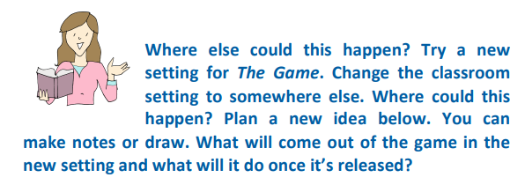

Instead of… | Your ideas…
what comes out of the game?
what will it do?
extra ideas

Now write your new problem, set somewhere else: start with the first strange event, then introduce the new threat and finally describe what the threat does.

