**Friday 24th April 2020**

**Maths**

**Mental Maths**

**7.** 

**8.** 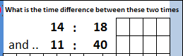

**9.** 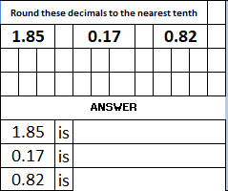

**10. Find ¼ of 92.**



2. 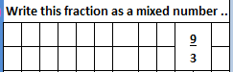
3. 
4. 
5. 

**6.** 

**Problem Solving**

**Step** 1 **Step 2**

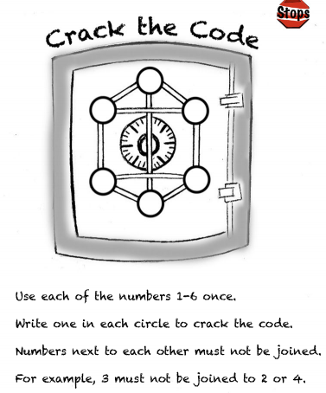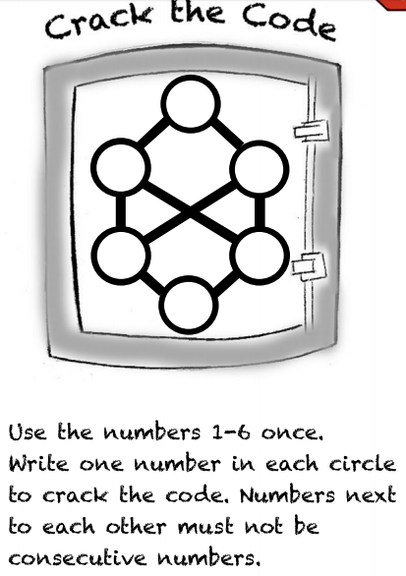

**Challenge!**

