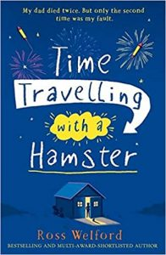
Friday
Time Travelling with a Hamster
pg. 87 - 91
Write a letter back to dad to tell him what you have done so far to act on his letters and instructions. Include some details about what has happened to you so far and how you are feeling about it all. Don’t forget to tell him that you don’t understand some of the theories in his letter and what you think will happen if you follow everything he asks you to do.

Don’t forget to include:
- an introduction – why you are writing
- informal language as you are writing to family
- commas for fronted adverbials and clauses
- first person as you writing from Al’s point of view

