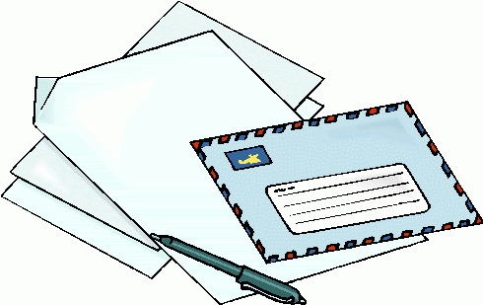
Friday 3rd April 2020
English

Imagine you are a chimney sweep in the Victorian times. Write a letter to your parents explaining what your life is like. Use the information given with the Artwork to help you.

