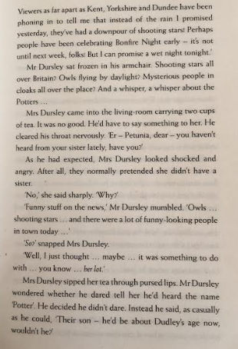
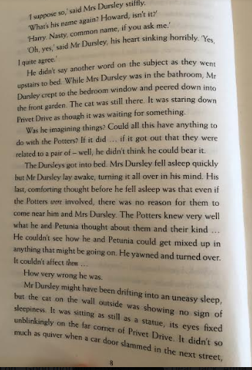
WCR Friday

Read pages 7-8
- Name me the 3 places people have been phoning in from?
- How did Mrs Dursley react when Mr Dursley asked if she had heard from her sister?
- What was the cat doing when Mr Dursley looked out of the window?
- What was Mr Dursley comforting thought before he went to sleep?
- Find and copy the simile the author uses at the end of page 8

