Geography homework menu-Year 1/2
Weather | 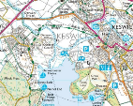  Mapping
Keep a record every day (in a diary form) for 2 weeks. What do you notice? Can you draw a picture to represent the weather? Are there any patterns to when it rains the most?  https://www.bbc.com/weather/2654993  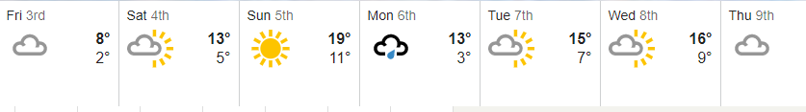  Use the link to see the weather forecast for the week, can you understand the symbols? | Can you make your own box map? (Remember to use symbols) Use a shoe box and put items inside!  Use the information attached to help you match the map symbols.  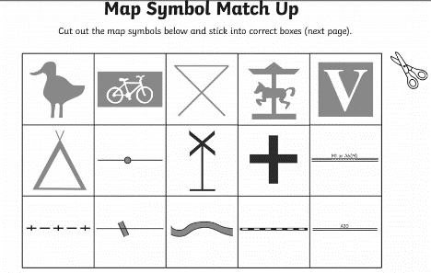
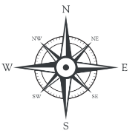  Compass | 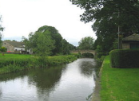  Rivers
Draw a compass use the 4 compass points. North, East, South and West.  Can you direct someone in your house to walk in a certain direction using the compass points eg, move 4 steps North, 2 steps West. | When at home and if you have access to a garden / yard please make a river using mud, stones, sand, anything from the garden. Take pictures to show your class teacher.  Go down to the Beck (as part of your daily exercise) and look at what is there! What do you notice etc?

