Geography homework menu-Year 3/4
Weather | 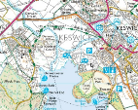  Mapping
Keep a record every day (in a diary form) for 2 weeks. What do you notice? Can you use the weather symbols to keep your record? Are there any patterns to when it rains the most?  https://www.bbc.com/weather/2654993  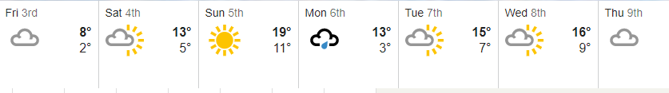  Use the link to see the weather forecast for the week, can you understand the symbols?  Can you research how different weathers can be recorded? | Use the information attached to help you match the map symbols.  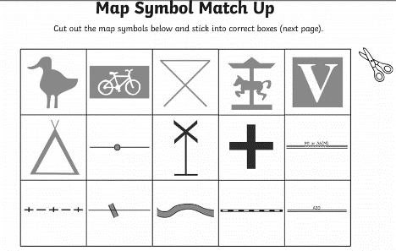  Take an OS map (part of) of an area of Allerton and draw a line from our school and describe all the items found on the line. If you set the line, you can have a list of symbols to check against.
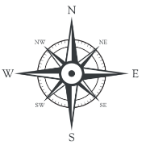  Compass | 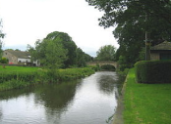  Rivers
Draw a compass use the 8 compass points. North, East, South and West.  Can you direct someone in your house to walk in a certain direction using the compass points eg, move 2 x3 steps North , 2 x 5 steps North West. | When at home and if you have access to garden / yard, make a river using mud, stones, sand, anything from the garden. Take pictures to show your class teacher. Can you make it steeper? What do you notice?  Linking to rivers , research about the water cycle. How does this link to your river that you have made?

