Geography homework menu-Year 5/6
Weather | 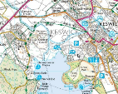  Mapping
Keep a record every day (in a diary form) for 2 weeks. What do you notice? Can you use the weather symbols to keep your record? Are there any patterns to when it rains the most?  https://www.bbc.com/weather/2654993  Use the link to see the weather forecast for the week, can you understand the symbols?  Can you research how different weathers can be recorded and understand the difference between warm and cold fronts? | Take an OS map (part of) of an area of Allerton and draw a line from our school and describe all the items found on the line. If you set the line, you can have a list of symbols to check against.  Repeat the above with map sections from a rural area and one from the coast – over an estuary is best as you get repeat symbols for beaches, mud flats, high water marks, etc!
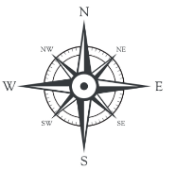  Compass | 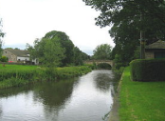  Rivers
Draw a compass use the 8 compass points. North, East, South and West.  Can you label your compass with 16 compass points?!  Can you direct someone in your house to walk in a certain direction using the compass points eg, move 2 x3 steps North , 2 x 5 steps North West. | When at home and if you have access to a garden / yard, make a river using mud, stones, sand, anything from the garden.  Take pictures to show your class teacher.  Extension: Create steep bits, meanders along the lower reaches, waterfalls, rapids, lake, etc  Remember to tweet your teacher!

