Our new unit is Gospel.
What can you identify in the image below? Label images, words, colours you notice and why you think they are important.
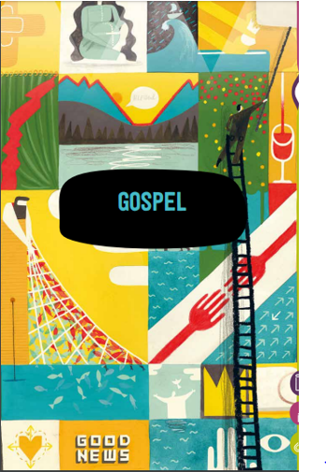
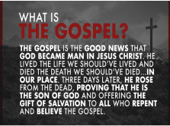
From the Old English 'god' meaning 'good' and 'spel' meaning 'news'

It is the record of Christ's life story and teaching in the first four books of the New Testament of the Bible.

--------------------------------------------------------------------------------------------------------------------------------------------------
We are going to be looking at the key question -
What kind of world did Jesus want?
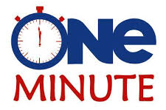
Speed write! Note down what you think.

Drawing what a ‘good’ Christian would do. | Situation | What I would do in this situation.
 | 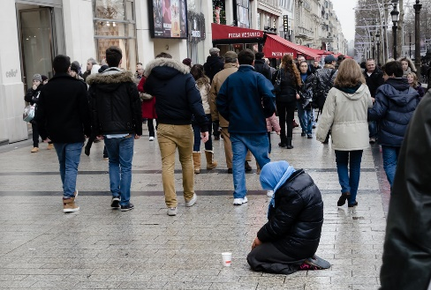

In the left-hand side box, draw what a Christian who lives as Jesus would want them to might do in each situation.
In the right-hand box, write you might choose to do in that situation, if you were trying to be really good and kind — (it does not have to be the same as what you think a Christian would do).

