**HISTORIANS in Year 2 should be able to:**

* Talk about the past and present using appropriate vocabulary e.g. recently, when their parents were children, decades, centuries
* Order people, objects and events using a given scale
* Ask historical questions and use information to help answer them
* Describe people, objects and events through writing, diagrams, models and timelines
* Use a wide variety of sources to find out about the past

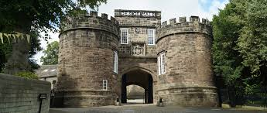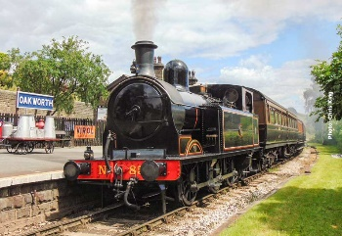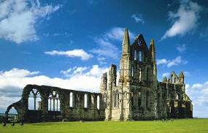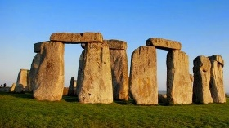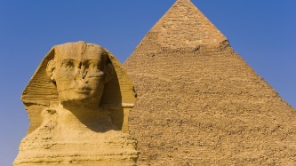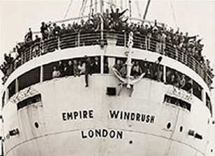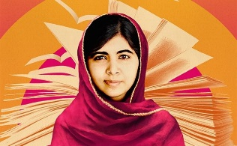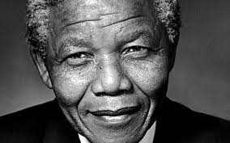

**HISTORIANS in Year 6 should be able to:**

* Talk about the main changes in a period of history using precise historical vocabulary
* Use a timeline to talk about changes and developments in culture, technology, religion and society
* Ask historical questions and choose reliable sources of evidence to find answers. Realise that there often is not a single answer.
* Choose how to present information for an audience using a wide range of methods, making sure that they use historical vocabulary and dates
* Use a wide variety of sources to find out about the past and give clear reasons why there may be different accounts of history.
* Evaluate evidence and select the most reliable form.

**HISTORIANS in Year 5 should be able to:**

* Talk about the main changes in a period of history using appropriate vocabulary
* Compare periods of history and notice any connections between them
* Use a timeline to talk about people, events and places they have found out about
* Ask historical questions and choose reliable sources of evidence to find answers. Begin to realise that there often is not a single answer.
* Choose how to present information for an audience using a wide range of methods
* Use a wide variety of sources to find out about the past and give clear reasons why there may be different accounts of history.

**HISTORIANS in Year 4 should be able to:**

* Talk about the past and present using appropriate dates, centuries, BC/AD and time vocabulary
* Tell the story of periods in history and begin to compare them
* Place people, events and objects that they have found out about on a timeline
* Ask historical questions and suggest a wide range of sources of evidence to find answers
* Present information about the past using a wide range of methods, that they choose themselves
* Use a wide variety of sources to find out about the past and explain why there may be differences

**HISTORIANS in Year 1 should be able to:**

* Talk about the past and present
* Order a few people, objects and events according to when they happened
* Talk and write about things that are the same and different from the past
* Ask historical questions
* Write and draw about the past
* Use books, stories, objects, people and places to find out about the past

**HISTORIANS in Year 3 should be able to:**

* Talk about the past and present using appropriate dates, centuries and time vocabulary
* Begin to tell the story of periods in history
* Order people, objects and events using a time line
* Ask historical questions and use a wide variety of evidence to find answers
* With help, present information about the past using a wide range of methods
* Use a wide variety of sources to find out about the past and begin to explain why there may be differences

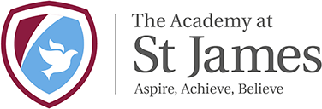

**Key Skills Overview Y1 – 6**

**HISTORY**