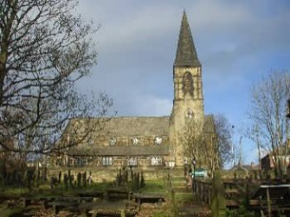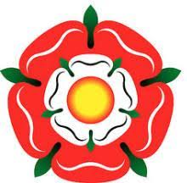

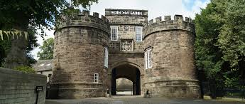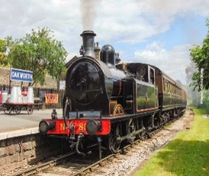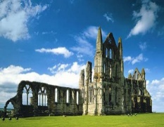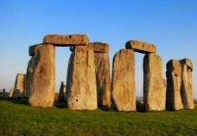



**History Vision**

By the end of their time at St James our children will:

Our vision is that our curriculum gives children a clear understanding of the past and how it has helped shape the modern world around us and placing our community at the heart. The children will develop their knowledge, and the skills of a historian.

Experiences:

* Know the stories of our communities and the events that have formed our place
* Have memories for life from visitors, visits and rich experiences

Subject discipline:

* Lessons develop historical concepts, skills and vocabulary.
* Chronology is used to develop an awareness of time, period and an overall historical narrative.
* Scrutiny and discussion of the reliability and usefulness of historical sources at an age appropriate level.
* Interpretation of historical sources to form own opinions on past events and people.
* Use with ease their understanding of change and continuity, similarity and difference, cause and effect, chronology and significance to interpret events and developments
* Questions are used to develop an enquiring, historical mind.
* Confidently carry out their own historical enquiries.

Knowledge and Vocabulary:

* Learning from a wide range of sources such as, documents, eye witness accounts, costumes, books, radio, images, interviews and sites.
* Recording in a variety of ways linking with other subjects, where appropriate.
* Have a broad and deep knowledge of regional, national and international history and well-developed historical thinking
* Use historical terms accurately in their effective communication of ideas and judgements
* Select and apply their knowledge and skills from other subjects to draw conclusions and communicate their finding

Ethos and Values for life:

* Children are aware that they are learning History!
* Feel prepared for the next stage of their history education and part of their adult life
* Feel proud of themselves, their communities and their place