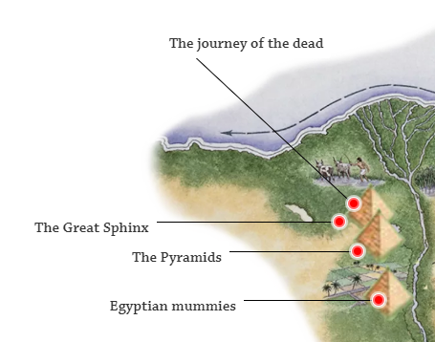
Why are the pyramids so important to the Egyptian people?
Website
https://www.bbc.co.uk/bitesize/topics/zg87xnb/resources/1
https://www.dkfindout.com/uk/history/ancient-egypt/

Can you make a non-chronological report based on the purpose of the pyramids?
Include:-
- How the pyramids were made?
- Who built them?
- What they were used for?
In your report add maps, diagrams and any other interesting facts that you can think of to make the report interesting.

