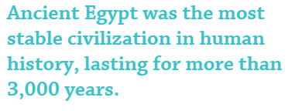
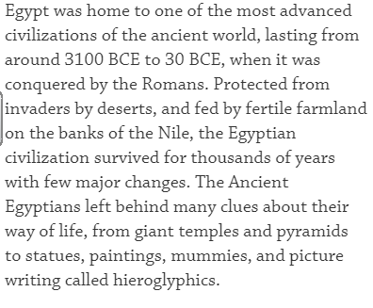

Can you explain why the physical features of Egypt helped support the lives of the Egyptians? Why was it possible to live and work in this country at this time?

Look at the map below; explain how the River Nile supported its community.

Log onto DK find out, click on each of the red dots and this will give you information about the land.

