How does light travel?

Use the website links to watch the film clips about how light travels.

https://www.stem.org.uk/resources/elibrary/resource/30672/modelling-light
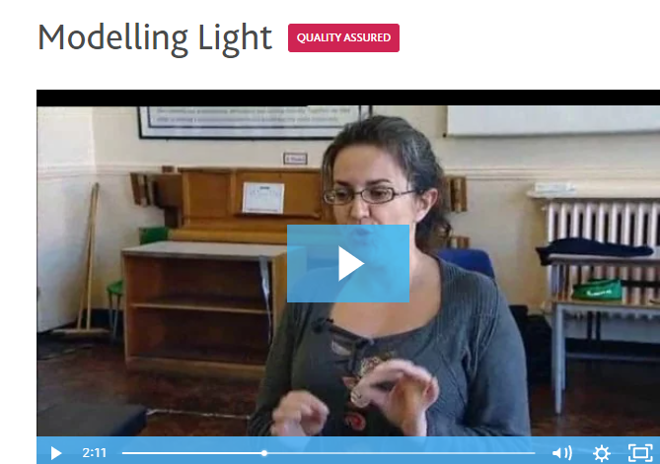

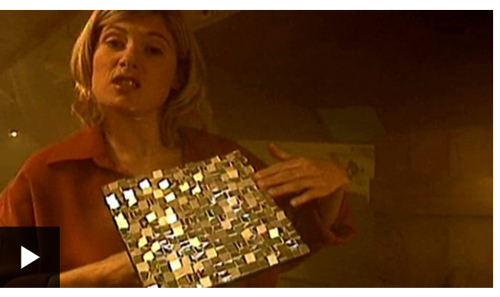
https://www.bbc.co.uk/bitesize/clips/zyntsbk

