RE – Islam
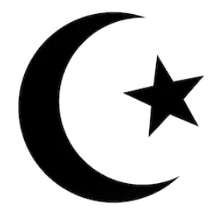
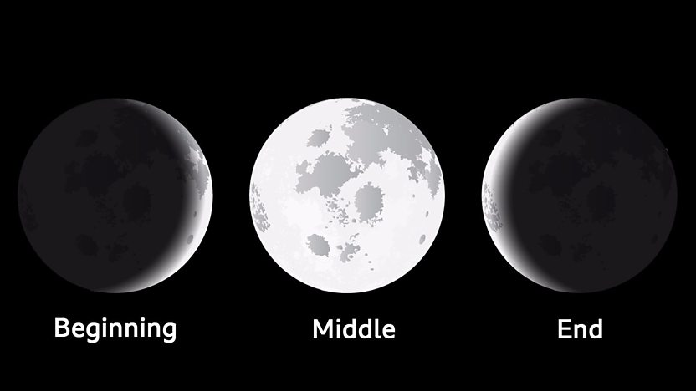
23rd April saw the start of Ramadan.
What is Ramadan? What happens during Ramadan?

Find out about Ramadan using the following links:
https://www.bbc.co.uk/bitesize/topics/zpdtsbk/articles/zjc2bdm
https://www.bbc.co.uk/newsround/23286976

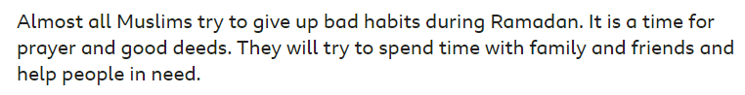
What bad habits will/would you try to give up?
What good deeds will/would you try to do?

You could make a video to discuss this rather than writing it all down.

