Art
Friday 3rd March 2020

Chimney Sweeps
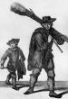
Chimney sweeping was a job children could do better than adults. Small boys (starting at the age of 5 or 6 years) would be sent scrambling up inside the chimney to scrape and brush soot away. They came down covered in soot, and with bleeding elbows and knees.
"I have two boys working for me. after work their arms and legs are bleeding so I rub them with salt-water before sending them up another chimney" Sweep Master
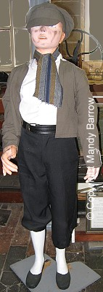
The chimneys were usually very narrow (in some cases as small as 30cm) and twisted. Children often got stuck or froze with terror in the cramped darkness - in these cases the Master Chimney Sweeper, would simply light the fire underneath to 'encourage' them to get on with their work.
The work was dangerous and painful. Some boys got stuck and died of suffocation.
"I never got stuck myself but some of my friends have and were taken out dead." boy aged 8
In 1832 the use of boys for sweeping chimneys was forbidden by law, however, boys continued to be forced through the narrow winding passages of chimneys in large houses.
'The Water Babies' by Charles Kingsley, tells the tale of a young sweep, Tom. who drowns while trying to escape from his evil master and comes back to life underwater as a 'water baby'.

Task: Create your own artwork to show what it would have been like as a chimney sweep.

Here are some examples to help you. You can draw a picture, paint, make a sculpture – use your imagination!
