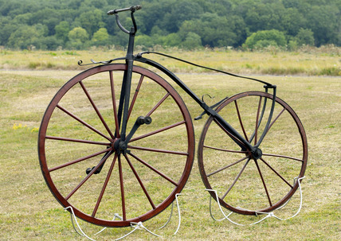
Tuesday 21st April 2020
History

How did transport develop during the Victorian era?

- Watch the following clip and make notes as you are watching https://www.bbc.co.uk/bitesize/clips/z4fvr82

- Use http://www.primaryhomeworkhelp.co.uk/victorians/carriages.html to further your knowledge of transport.

Task: Create a non-chronological report about the different types of transport throughout the Victorian era.

- Describe a range of transport and how it was developed
- Explain how machinery such as steam engines helped with the Industrial Revolution

Your non-chronological report can be either a single or a double page spread, handwritten or typed. Make sure to include pictures and captions.

