RE – Salvation
Key Question – What did Jesus do to save human beings?
What are your thoughts? You could represent your thoughts in pictures with annotations or you could make a video response and post it to your dojo portfolio!
What do other people in your family think? You could interview them on video too!

Read the scenario below and answer the questions. How could this relate to our key question?
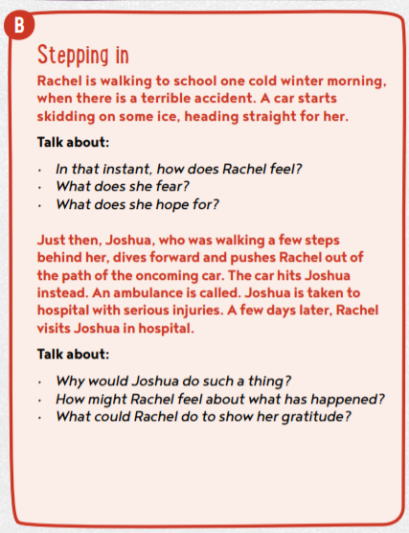
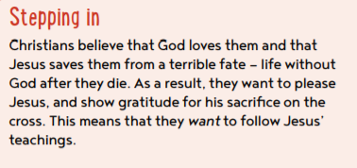
Would you step in to save someone else?
Why? Why not?

