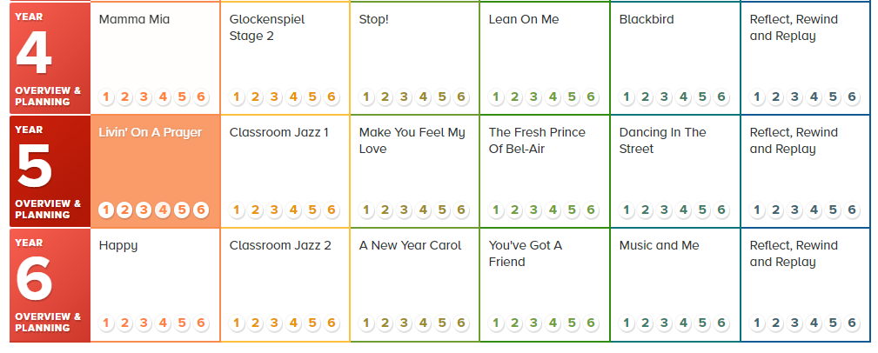
Long term plan - Music

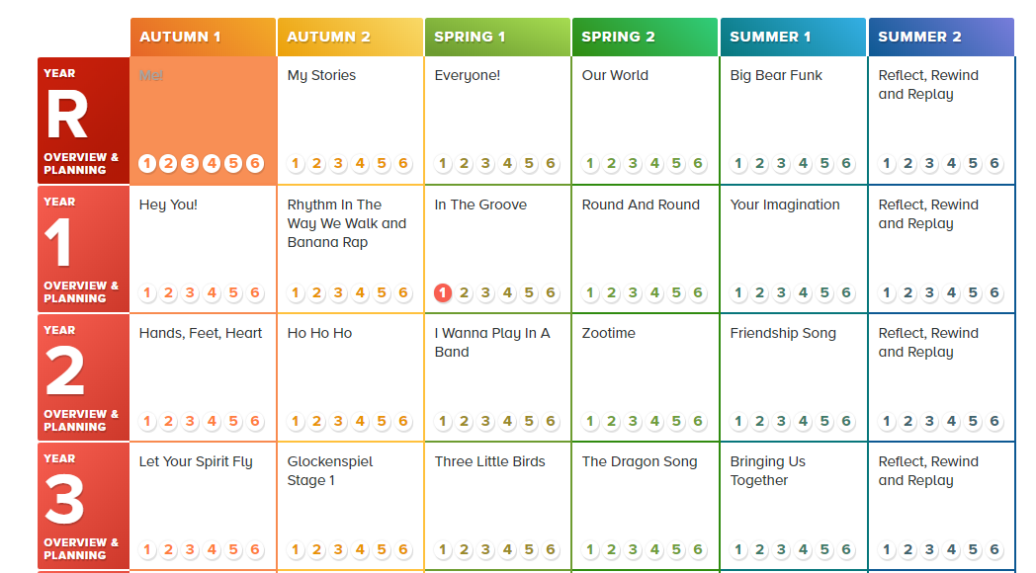
How the Scheme is structured
Each Unit of Work comprises the of strands of musical learning which correspond with the national curriculum for music:
- Listening and Appraising
- Musical Activities
  - Warm-up Games
  - Optional Flexible Games
  - Singing
  - Playing instruments
  - Improvisation
  - Composition
- Performing

