**Monday 20th April 2020**

**Maths**

**6.** 

**7.** 

**8.** **x means ‘of’ - 1/8 of 72**

**9.** 

**10.** 

**Mental Maths**

1. 
2. 
3. 
4.  **Convert to same denominator first**
5. 

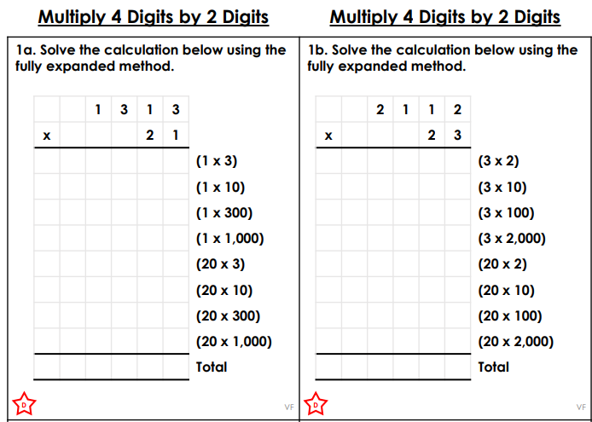

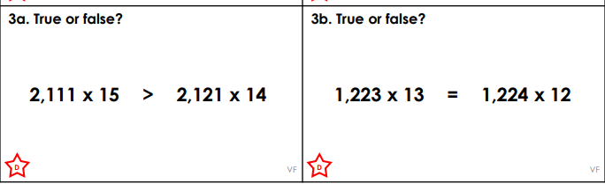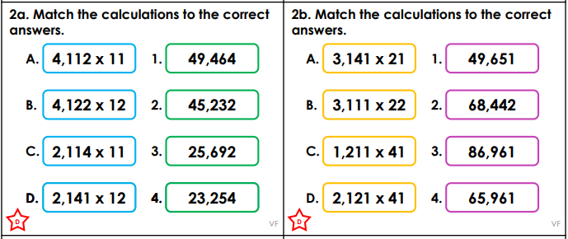

**Challenge**

