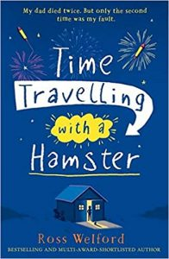
Monday
Time Travelling with a Hamster
pg. 70 - 73
- Why does Al think Grandpa Byron looks cool? Find and copy two reasons.

- “His voice tails off and he takes another puff.’ pg. 71
What does it mean when it says Grandpa’s voice tailed off? Why is this?

- Find and copy the phrase that tells you Grandpa Byron is unsure of Jolyon and a bit suspicious.

- Why does Al hate himself at this part of the story?

