Normally, before we start our new text, we ask you to make predictions based on a Word Cloud and some images. However, this time, we are going to tell you what our new book is!
Our Whole Class Reading text for this term is….
Harry Potter and the Philosopher’s Stone!
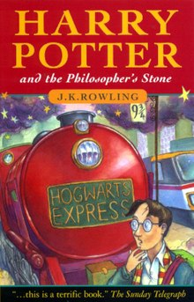
We think most of you will have heard of Harry Potter and maybe seen some of the films. Based on your knowledge and what you can see from the front cover, we would like you to create a Word Cloud for this novel.

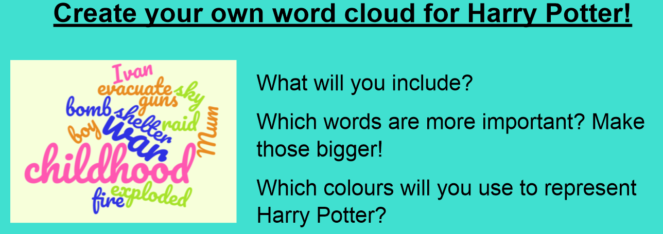

Based Share your word clouds with us, and explain your word choices, the colours you decided to use and why particular words were larger than others.

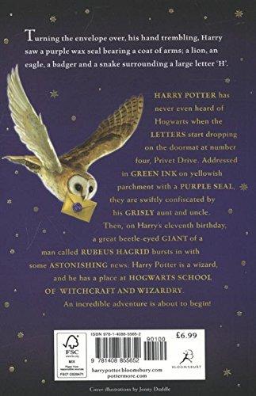

After reading he blurb, answer the following questions:
- Which verb tells the reader that Harry was excited or scared?
- Which five animals do we learn might be important from the back page?
- At which address does Harry live?
- Find and copy the adjective, which is a synonym for ‘gruesome’ and ‘horrible’.

