Time Travelling with a Hamster
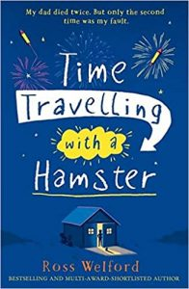
pg. 46 – 51
Draw what you read
He was staring up at what must have been the starriest sky I had ever seen. There were no streetlights, and Seahouses was a mile behind us and round a curve in the road. The sky wasn’t even black, it was a sort of dark navy, and there were so many stars that some of them merged into one another and formed smudges across the sky.
It was a chilly night and Mum said that she wanted to hurry back to the cottage, so it was just me and Dad. “Come on,” he said. “I’ll show you something.” He hopped up over a gate into a field and turned back to help me follow him over. We walked together over the black-green grass, the only light coming from the stars, and then we laid down on our back, gazing upwards. I felt Dad’s hand reach over and grip mine.

