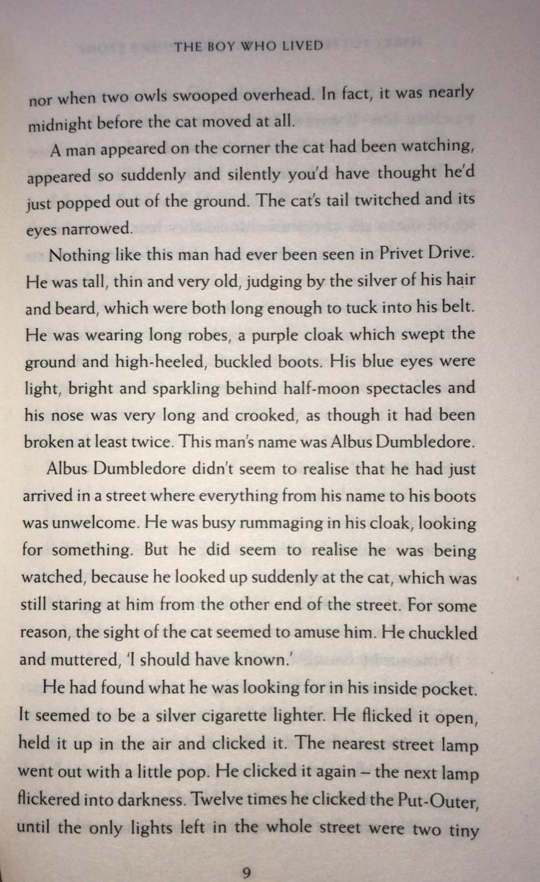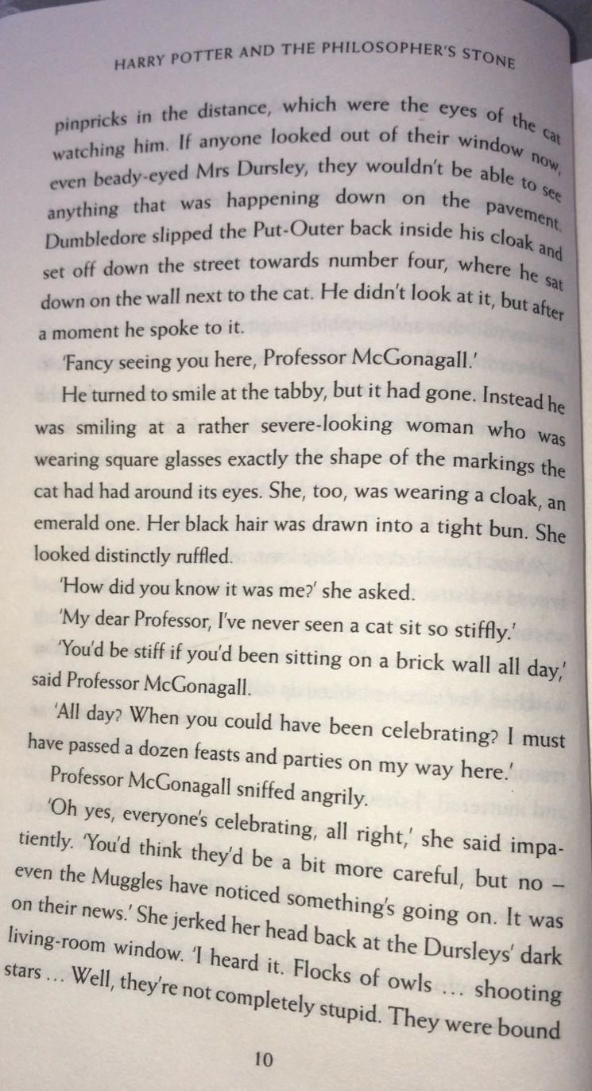
Sequence these statements from 1 -4 in the order they happen.
The tabby transformed into a human.
Dumbledore chuckled, when he spotted the cat.
Dumbledore sat on the wall next to the cat.
McGonagall gestured to the Dursley’s living room.

How many times did Dumbledore click the Put-Outer?

________________________________________________

Where was the Put-Outer put?

_____________________________________________________________

Read the paragraph beginning, ‘He turned to smile’.
Find and copy the phrase, which tells us McGonagall looked disturbed.

_________________________________________________

Re-read the paragraph beginning, ‘Nothing like this man had ever been seen in
Privet Drive’.

Use the information to draw a portrait of Albus Dumbledore, using only the
information in the text.
Label your image with key words and phrases.

