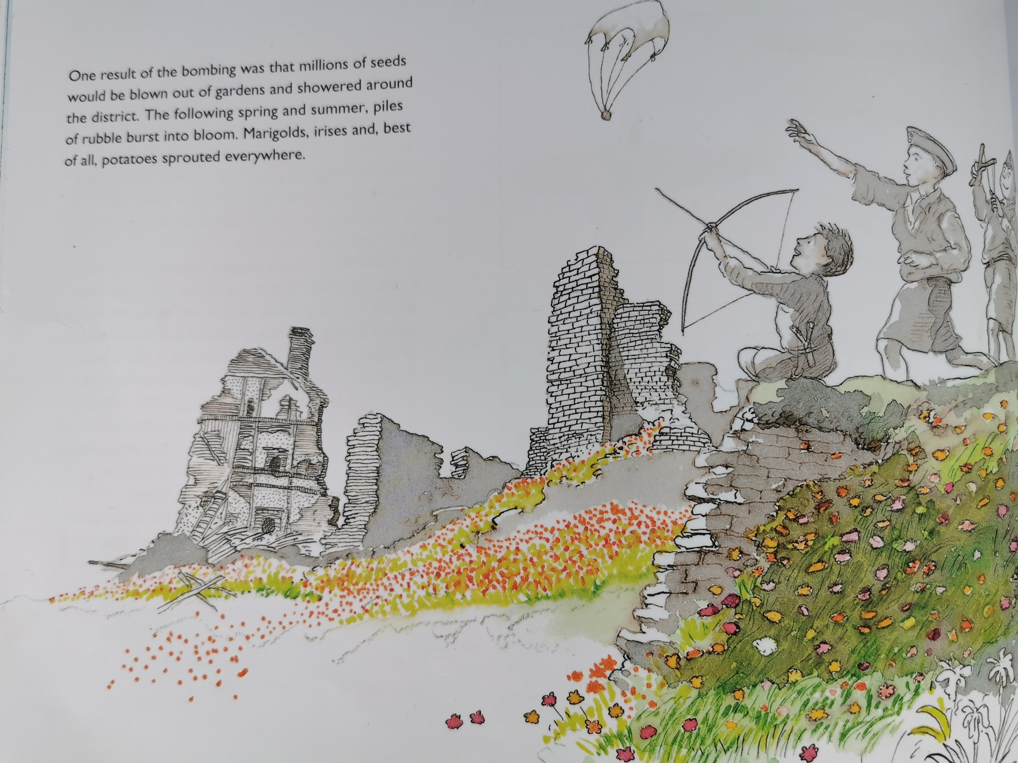
- Find and copy the phrase, which informs the reader that the rubble dramatically became colourful.

- Where did the seeds come from?

- In which two seasons did the flowers appear?

- Why do you think the author says, ‘best of all, potatoes sprouted everywhere’?

Oracy statement
Consider reasons why you agree and disagree with the statement
Upload your thoughts on Google Classroom, either by video, photos of your work on paper or written messages.
Let’s get debating!
Research the flowers mentioned on page 56.
Can you draw marigolds, irises and potato plants and find out facts about them?

Take photos of them, if you spot the flowers in Warboy or on the link below in your garden or local surroundings!
https://www.woodlandtrust.org.uk/trees-woods-and-wildlife/plants/wild-flowers/

