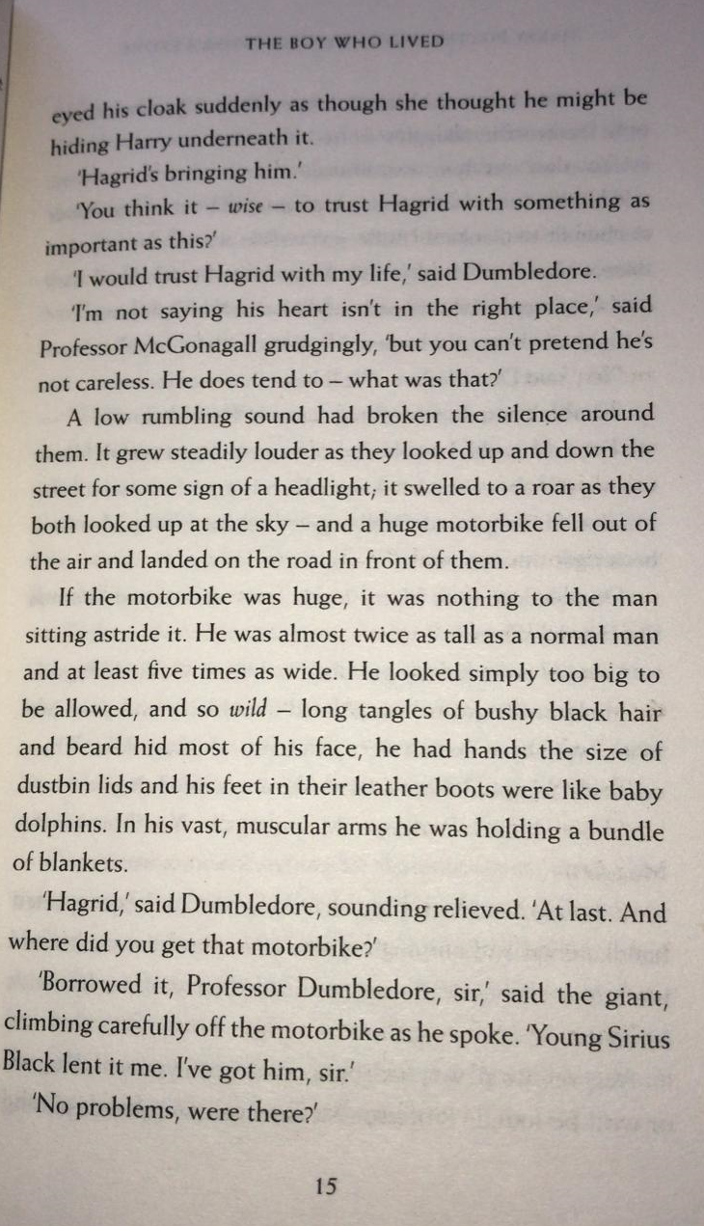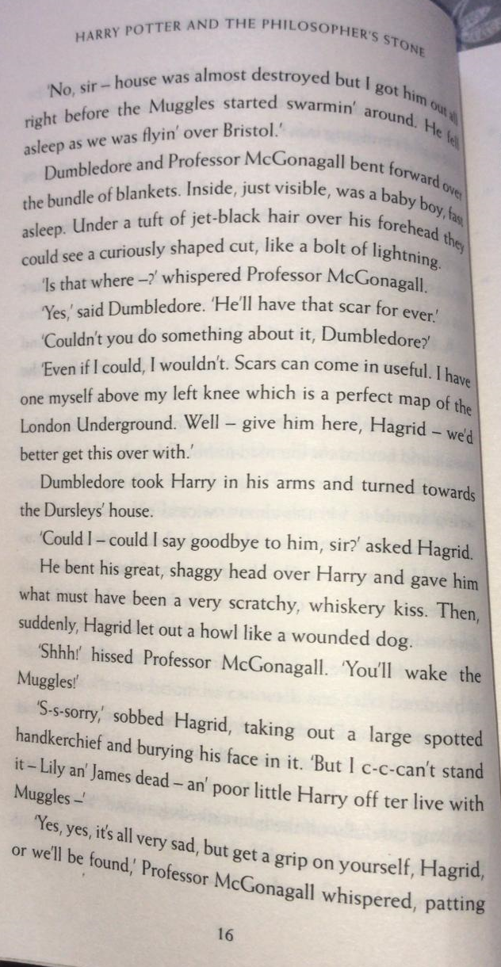
Below is a photograph of Hagrid from the film version of Harry Potter.
Based on the text description on page 15, label Hagrid’s features.
Do you notice anything different about the book and film characters?
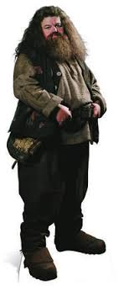

Challenge - write at least one thing that you can infer about Hagrid from the description. Explain your inference!
(Inference example: if someone slammed a door, we could infer they were angry)

Page 16 Questions
- Why was baby Harry ‘just visible’ when Dumbledore and McGonagall bent forward?
- What ‘curious’ feature did Harry have under his jet-black hair?
- Why did McGonagall hiss at Hagrid and tell him to ‘get a grip’?

