Thursday 23rd April 2020
Science

What I learnt last half term about life cycles… | What I learnt last half term about plants…
What I learnt last term about Earth and Space… | What I learn last year about rocks…
Memory Quiz

Key Question: Do mammals have the same gestation period?

What is a gestation period?
This is the length of a pregnancy from fertilisation to birth. The fertilisation occurs when male and female gametes (sex cells) come together to create an embryo. The following amount of time in the womb, up until birth it the gestation period.
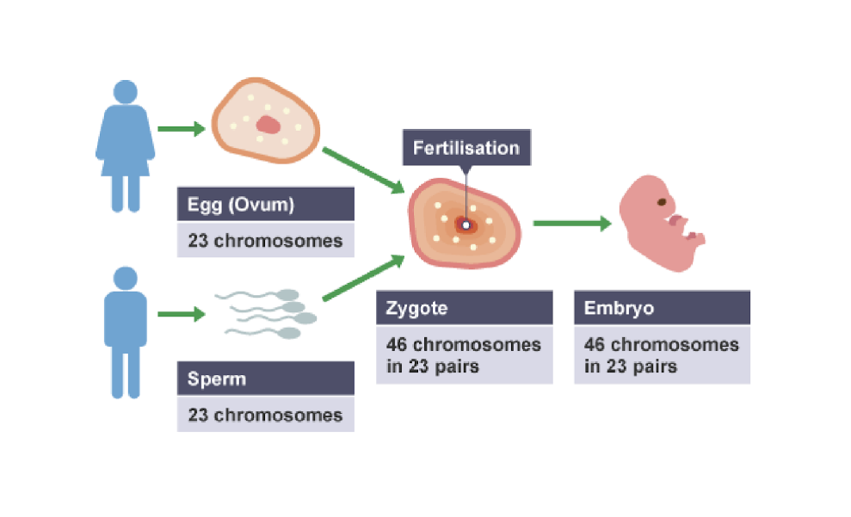

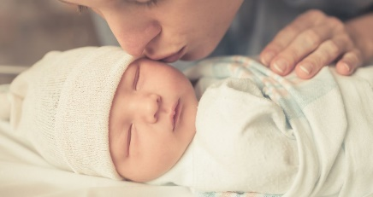
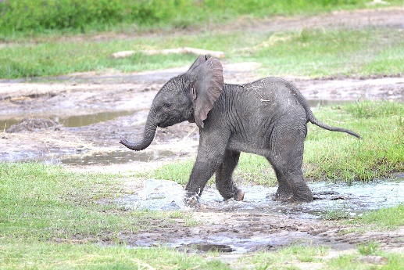
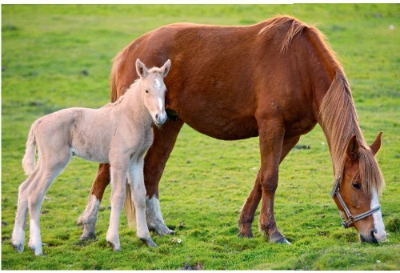

Do mammals have the same gestation period?

Task: You need to research the length of gestation in the following mammals. Fill in the following table. The first one has been done for you.
Do you spot a pattern at all?

Animal | Gestation Period | Name of offspring | Average number of babies per pregnancy | Average life span of the animal
Dog | 58 – 68 days | Puppy | 5-6 | 10-13 years
Cat
Cow
Chimpanzee
African Elephant
Fox
Giraffe
Goat
Hamster
Horse
Rabbit
Human

Any patterns found?

