Thursday 2nd April 2020
Maths

Decimal sequences
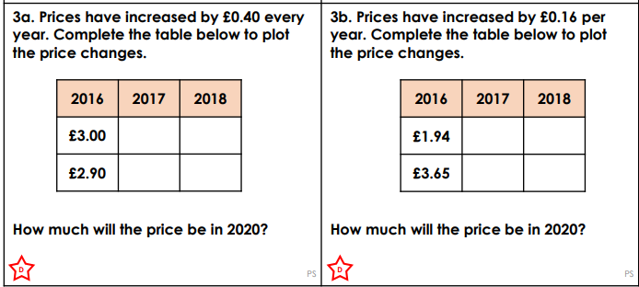
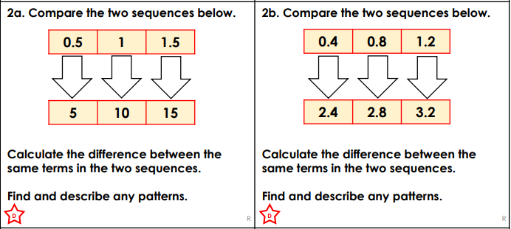
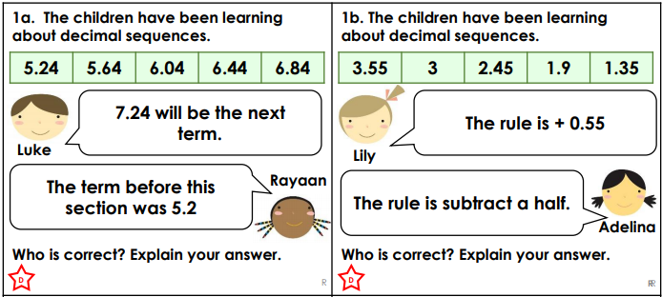

Challenges
- Spot the mistake 0.088, 0.089, 1.0

- What comes next? 1.173, 1.183, 1.193

