Thursday 2nd March 2020
English

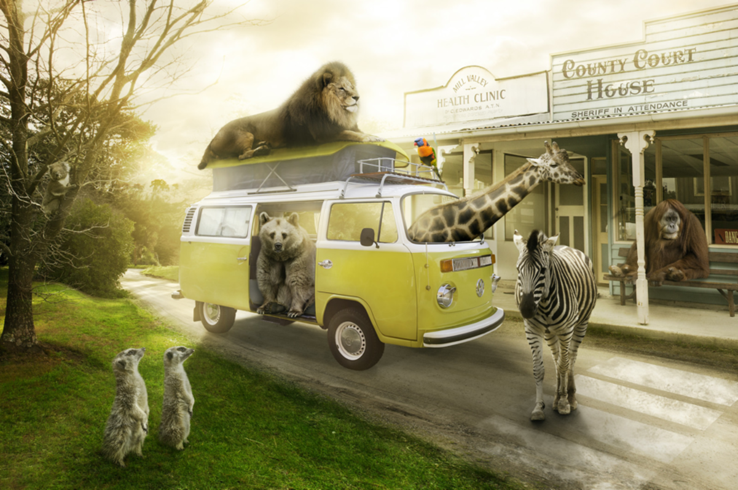

Story starter!
Most visitors are a little shocked (to put it mildly) when they arrive at Animal Town. Despite the fact that the name of the town gives a slight indication to passers-by that the inhabitants of the town are ‘not normal’, it’s as if people don’t believe things until the see them with their own eyes!
Once you get used to being in Animal Town – or so they say – seeing an orangutan behind a desk in a sheriff’s office and upholding the law to an impeccably high standard becomes relatively ‘normal’…
Imagine you are a visitor in Animal Town. Try to describe your experience.
Alternatively, you could be one of the residents…

Perfect picture!
Can you draw a picture of what a scene looks like in the supermarket in Animal Town?

