Thursday 30th April 2020
English

The Adjective Game
Adjectives describe a noun, for example:
The red car drove down the misty lane.
You can change the mood of your writing by choosing your adjectives carefully. Read this description of the Tarantula.
The handsome Tarantula looked at the children. Its glistening, hazel eyes scanned the room. Delicate hairs covered its plump body and swayed like shimmering grass. Its solid legs, like thick branches, stood strong.
- The spider sounds quite pleasant. However, if we change the adjectives, you can make it sound much more scary. Give it a try! Fill in the gaps with an adjective that will help to make the spider sound gruesome.
The __________Tarantula looked at the children. Its _________ , ________ eyes scanned the room. _________ hairs covered its _________ body and swayed like __________. Its ______ legs, like ____________, stood strong.

At that moment, the table began to shake, then the windows rattled and the floor vibrated. Everyone stopped what they were doing and the room fell silent.

“EARTHQUAKE!” shouted Billy, bursting into laughter. He soon stopped, as in a blink of an eye, an enormous spider, bigger than a horse, shot out of the game and landed in the centre of the crowded classroom. Everyone froze. Its enormous, hairy legs were tensed, ready to pounce and its whole body seemed to pulse. Eight bulging eyes scanned the room and then…

It sprung into action. It crushed the tables, smashed the windows and flung children all around the classroom with a flick of its legs. It powered towards Mrs Allbright as she stood rooted to the floor in terror. The room was filled with shrieks of panic and despair.
“What shall we do?” shouted Danny desperately, pressing himself tightly against the wall.
“Read the instructions,” ordered Sally, “We have to stop it!”
What other problems could the game cause? What else could come out of the game and what would it do?
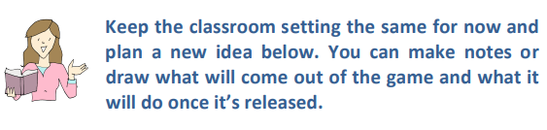

Instead of… | Your ideas…
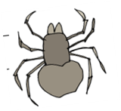
… crushing the tables
… smashing the windows
… flinging children round the room
… grabbing the teacher
…extra ideas

