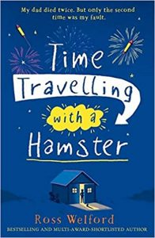
Time Travelling with a Hamster
p. 38 – 41
Choice of vocabulary and phrasing
1. ‘It isn’t fast enough to avoid a glimpse of Steve’s crestfallen face.’
What do you think ‘crestfallen’ means?

2. What do you think the phrase ‘I figure it’s wise to steer a very cautious path’ means?

3. What do you predict will be in The Letter? Is he going to get into trouble for opening it early? How will anyone know?

