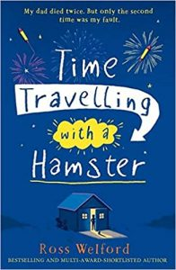
Time Travelling with a Hamster
pg. 62 – 65
Out of the nine new things Al found out about his dad, which do you think are the top 5 most important? Why?

1.
2.
3.
4.
5.

