WCR Thursday
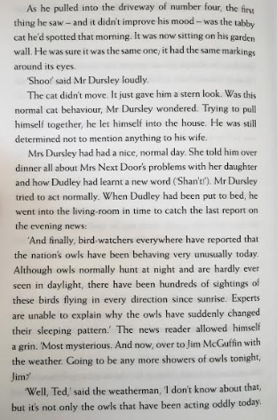
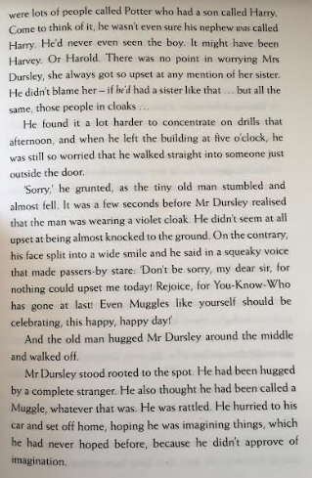

Read pages 5-6
- Why wasn’t he concentrating when he walked straight into someone just outside the door?
- How do you think Mr Dursley was feeling when he was called a ‘Muggle’
- On Page 5 what word means Mr Dursley was shaken after the experience with the stranger?
- What word did Dudley learn that day?

- Reading page 6 what 2 facts do you learn about Owls?

