Tuesday 21st April 2020
Maths

Mental Maths
Complete the pyramid using addition. An example has been done for you.
You can set yourself a target of long it will take you. Then, time yourself to find out how long it actually takes you.
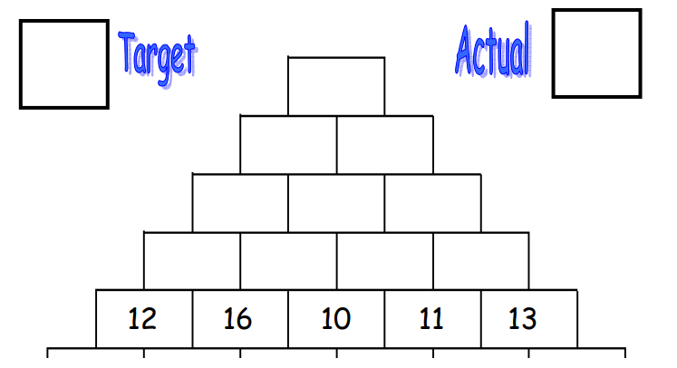
28

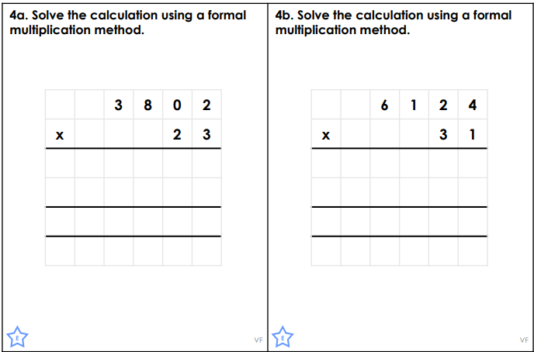
Main Activity

Not expanded, like how we do it in class. Remember to use a 0 as a place holder on your second line.

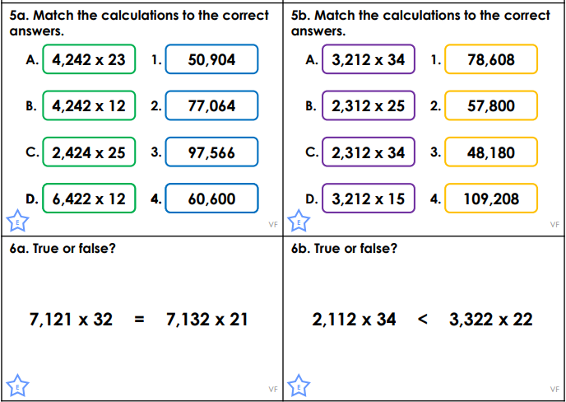

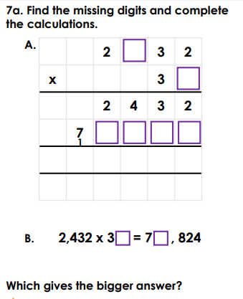
Challenge Challenge 2
