Time Travelling with a Hamster
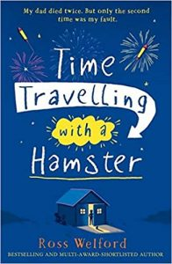
pg. 52 – 57

Three things I know so far… | Two things I’m not sure of… | One question I want to ask…

